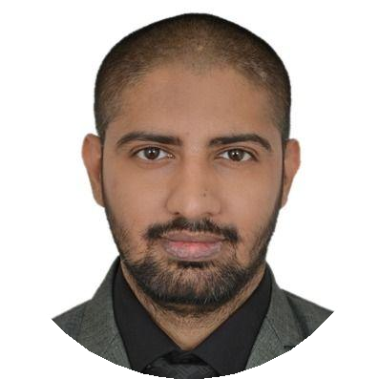
Altaf

Email: altaf.387890@2freemail.com

A professional dentist with 8+ years of progressive experience from acting as an intern to running and managing my own Personal clinic “MR.Dentist ‘’ from past 6 years. Superior interpersonal and analytical expertise with a ﬂair for increasing organizational cohesiveness and proﬁtability, talent assessment and employee engagement.

WORK EXPERIENCE

OWNER/DEIRECTOR
MR. DENTIST
02/2013 – Present
We provide a range of services to our patients. Meeting with patients, assess their dental health, perform scheduled cleanings, handle complex procedures, such as root canals, extractions, and oral surgery, and work with other staff members and professionals, such as dental hygienists , surgeons, Orthodontists and assistants, to provide our clients with quality dental services. Our Motto was to provide correct diagnoses and treat dental issues along with helping patients develop better oral hygiene regimens.
Achievements/Tasks
Aesthetic restoration and crown buildup successfully treated for
500+ cases.
Smile designing and veneering done successfully creating straighter, whiter and beautiful natural looking smiles.
Root canal Treatment of more than 2000+ cases with a success ratio of 95%, which includes cases with all kinds of complexities like Dilacerated roots, C-shape canals, blunderbuss canals, severely calciﬁed, by-passing broken instrument in canals.
Extraction of all kinds of teeth aprrox 3000+cases and also
Disimactions mostly mesioangular.
Successfull placement of crowns and bridges done with special attention to margins, retention, stability, shades and occlusal harmony.
Mentor, Train and supervise junior staff to ensure they meet necessary clinical standards.

Franchise owner/co-director
ASIAN INSTITUTE OF ADVANCED DENTISTRY (MUMBAI)
10/2015 – 10/2017
continued dental education certiﬁed programmes
Achievements/Tasks
course director, hands-on mentor.
Successfully conducted cde programmes for basic implantology and fellowship, basic endodontics and fellowship, aesthetic and veneers,periodontology and oral surgery,lasers and orthodontic programmes.
successfully accomplish management and organization of all courses on time and synchronizing staff and students schedules and needs for better learning.
SKILLS

Aesthetics Smile Designing Veneers

Full Mouth Rehabilitation

Crowns and Bridges Root Canal

Disimpactions

CERTIFICATES

DHA eligibility letter (06/2018 – Present)

basic life support(AHA certiﬁded)

EDUCATION

B.D.S
M.A.RANGOONWALA DENTAL COLLEGE
06/2006 – 06/2010

ORGANIZATIONS

MR. DENTIST (02/2012 – Present)
DIRECTOR

ASIAN INSTITUTE OF ADVANCED DENTISTRY, MUMBAI
(10/2015 – 10/2017)
FRANCISE OWNER/DIRECTOR

LANGUAGES

english

hindi

Asso. dentist
parmar dental clinic
01/2012 – 12/2012
Achievements/Tasks
succesfully carried out all types of general dentistry procedure
marathi

INTERESTS

Contact: dr.vishal parmar
reading gaming football

