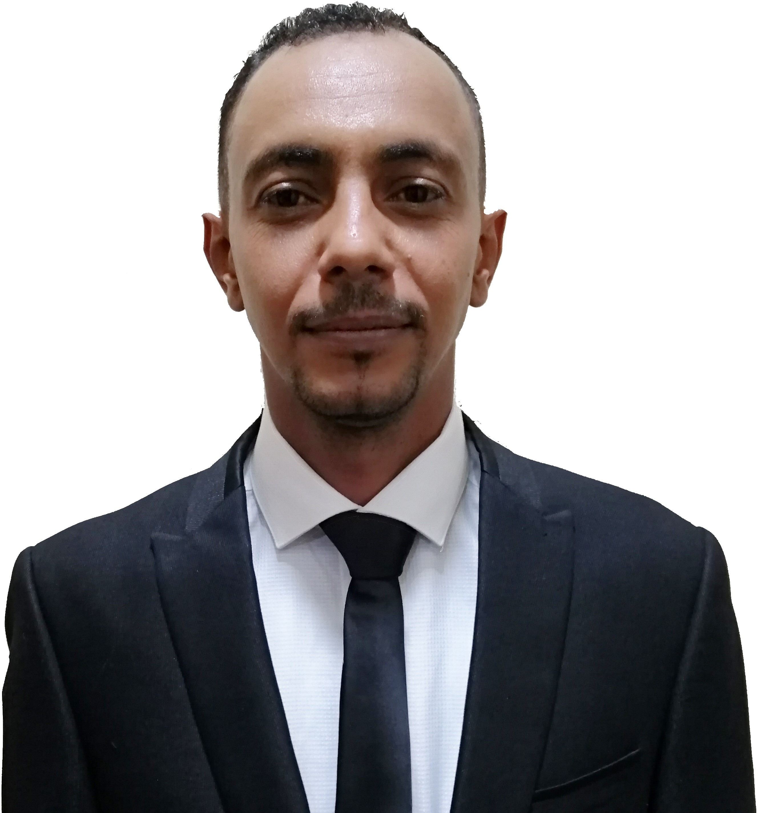

Mazin
Email: mazin.387900@2freemail.com

Professional Objective:

Driven sales representative with 10 years of experience in the sales field and customer service. A high level of product knowledge and an ability to quickly learn details about new market strategies and theories. A commitment to building customer relationships by reaching out to new clients and nurturing positive interactions with existing customers. Extremely skilled in explaining product features and benefits to customers, negotiating packages and pricing and closing sales deals.

Strengths

- Ability to rapidly establish and expand strong market presence and achieve solid sales growth
- Attended various sales seminars
- Highly motivated and driven, with the ability to achieve aggressively high goals
- Outstanding ability to build solid rapport with customers and internal suppliers
- Highly skilled and well organized in providing customer service, order processing, and cashier management
- Possess an active, energetic, and lively personality, with the ability to engage customer interest and attention
- Outstanding written and oral communication skills
- Proficiency in MS word, MS access, Power Point and other computer applications
- Highly innovative, resourceful, and proactive
- Remarkable ability to convince, persuade and close successful deals
- Extremely effective networking techniques and outstanding interpersonal skills
- Solid expertise in sales, business development processes, and marketing
- Excellent ability to demonstrate, promote, and sell
- Capable of working in a team or individually

Professional Experince & Main Achievements:

  - PETROBASH MA. CO.LTD®- Sales Representative
(From June 2017- current)

    - Sought out new clients by using current established network of contacts with attendance at industry trade shows, conferences, workshops and other networking events.
    - Educated new and existing customers about the features and benefits of products for sale by visiting clients on site and demonstrating potential uses and solutions.

PETRONAS MARKETING SUDAN® - Executive sales area
(From Nov 2015- May 2017)

    - Created detailed sales contracts for new and existing clients when products and services were ordered and walked the customer through all of the terms and sections.

Afro king® for Cars oils and grease : -
- Retail Sales Supervisor. (from 1stJuly 2012- 31stJan 2015)
- Managing Director of the center for Khartoum state sales. (from 1st Feb 2015 - OCT 2015)

  - Initiation and Implementation of Retail Section -from scratch
  - Surpassed quarterly sales goals targets by 15 percent with increased attention to customer education and devotion to friendly customer service.
  - Increased the rate of customer retention by 18 percent within the first year of employment by focusing on weekly existing client contact and feedback.
  - Provided timely and comprehensive solutions and answers to client questions about product issues when asked.

  - MTN Sudan®- Service Center Agent. (From Sep 2008 - Jun 2012)
- Employee star performance award , Oct- 2011.
- Supported a sales associate staff of 12 by managing customer databases, preparing correspondence and sending out sales contracts.
- Communicated with clients on behalf of sales associates when there was a concern or a question about a product or service.
- Represented the company at quarterly trade show events by working a sales booth station and providing information about products and services.

Educational formation:
- B.SC. Honor in Business Administration
(Alneelain University) Dec2009.

- Diploma. Information Technology
(Alneelain University) Nov2006.

Training &Certificates:

- New Horizons Egpt-Alexandria ,Professional certificate completion of
project management professional V.4 (P.M.P) ,Oct-2010.
- International center for quality (ICQ ) ,Certificate of Service Quality management ,Aug-2010.
- International center for quality (ICQ),Certificate of Sales techniques ,Jun- 2011 .
- Aptec in khartoum ,Certificate of advance Excel ,Dec-2011.
- PHOENIX Educational Institue –Dubai ,Certified Sales and Marketing Profissional ,Jul-2013.
- GTSC – Lubtricant and Greasing ,Jan-2015.
- Britich council sudan, Certified IELTS, Oct 2017.
- International License Certificate.

