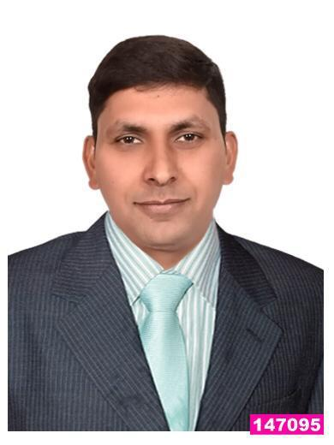
Bijender
Email: bijender.387905@2freemail.com
Asst. Banquet Manager

I completed my degree in Hotel Management and Catering Technology and Tourism from A-IHM, in 2007-2010 (Affiliated to PTU University, Jhalender). The knowledge I have acquired over the course; I am putting myself into practice, with a complete professionalism and dedication. My total work experience is of more than seven years with the one of world’s best properties, Hotel Le Royal, Hotel Clark's Avadh, Country Inn & Suites By Radisson and now with The Pride Group of Hotels “Ultimate in Luxury Business and Corporate Conferences” as a “Food & Beverage Service Profession”.

Experience

2016-12 - | Asst. Banquet Manager
present | The Pride Hotel Nagpur
 | Responsible for supervising daily operations of banquet area to ensure proper
 | procedures and optimal level of service, quality, and hospitality. Plan and confirm
 | all specific requirements and expectations concerning events.
 | • | Developed a strong service oriented professional banquet team of 25 people
 |  | through training and group feedback involvement
 | • | Maintain a 98% service score on Meeting Scope, a survey based monitoring
 |  | system.
 | • | Created a department training manual, standard operating procedures, and
 |  | cost control strategies.
 | • | Decreased beverage costs by 10% and labor costs by 15%
 | • | Exceeded projected budget by 12%
 | • | Introduced IDS and POS system procedures to improve internal operations
 | • | Organize and execute all catered functions.
 | • | Maintained & Updated daily & monthly reports

2016-04 - | Asst. Banquet Manager
2016-12 | Country Inn & Suites By Radisson Bathinda
 | Responsible for the management, supervision, scheduling and development of
 | large service staff.
 | • Handled all executive, administrative, and operational functions, including
 |  | but not limited to staffing, event materials and inventory planning, set up and
 |  | overall supervision and management of the success of planned events.
 | • | Managed five Captains, fiveteen full time Banquet servers and fifteen on call
 |  | servers
 | • | Created schedules for servers in accordance to the level of business.
 | • | Mediated interpersonal disputes.
 | • | Oversaw events varying in size from 2 - 2200 people.
 | • | Maintained high customer service and quality standards in all areas of
 |  | banquets.

2015-01 - F&B Executive

2016-04 | Country Inn & Suites by Radisson Meerut
 | Work closely with sales department in planning and detailing and provide
 | recommendations for a successful event.
 | • Managed employee schedules to ensure proper staffing of banquet events
 | from set-up to breakdown.

Personal Info

Date of birth

1988-01-01

Skills

IDS

Opera

P & L, MIS Reports

Sales & Promotions

Self-Motivation

2012-09 -

2015-01

2010-10 -

2012-09

2009-04 -

2009-09

- Manage and train all banquet employees so that they adhere to Hotel Standard.

- Execute events upwards of 1000 guests in a fast paced banquet facility.

- Maintained and updated daily and monthly reports.

- Detailed oriented and the ability to resolve issues under limited time constraints and to provide a high standard of customer service for guest satisfaction.

F&B Executive

Clarks Avadh, Lucknow

F&B Steward and Captain

Hotel Le Royal

Industrial Training

Centaur Hotel – New Delhi

Education

2010 B.Sc. In Hotel Management: Hotel and operations

Agra Institute of Hotel Management – Agra-UP

Additional Activities

2013 Employee of the month

