Daniel
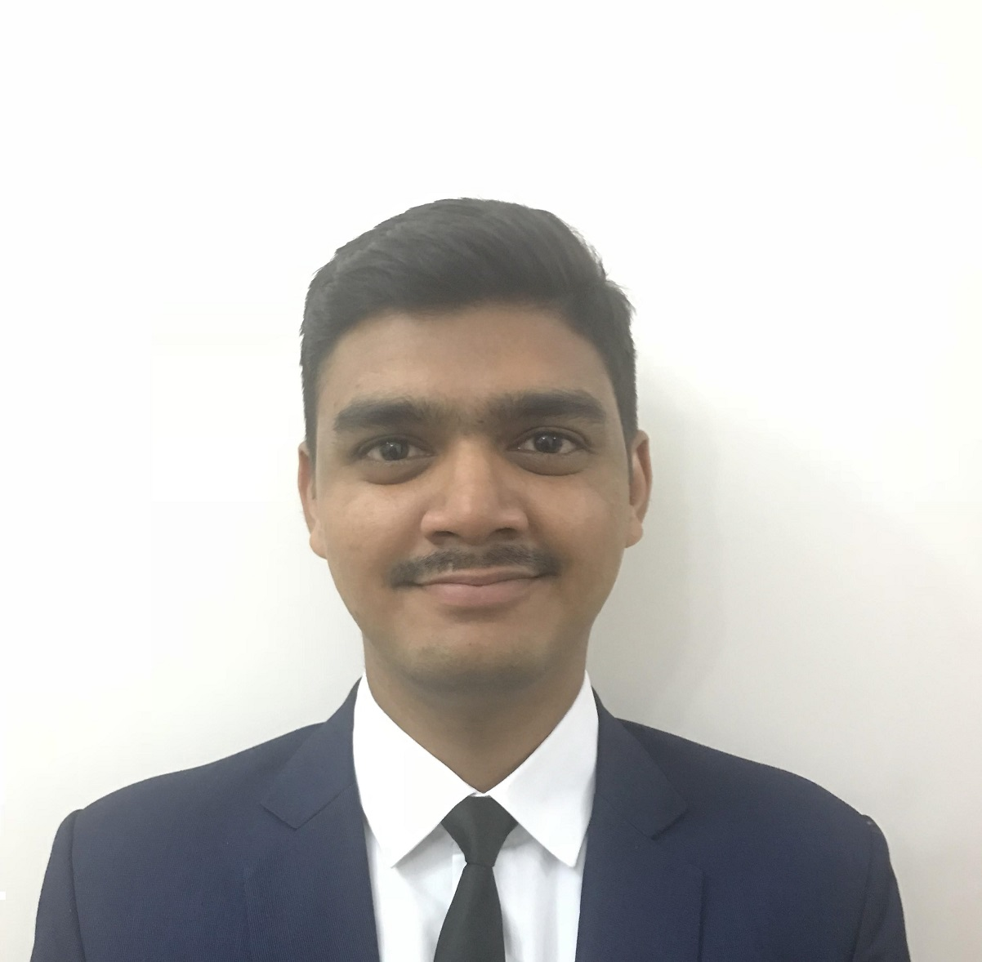

Email: Daniel.387971@2freemail.com

Objective
To establish a long-term career in the logistics industry with opportunities for career growth and to enhance my educational and professional skills in a stable and dynamic workplace.

Key Strengths

- Excellent written and verbal communication skills
- Flexible and can easily adapt to the required working conditions
- Can work well under pressure, and Capable of learning new procedures and formats quickly
- A complete team player

Professional Experience

aPRIL 2017 – jUNE 2017

Internship / Bosch, Goa - India

(Packaging Technology Division)
- Worked in stores department with SAP software using transactions to check for part location and stock
- Kitted parts for various projects and learned how projects are classified depending on parts needed for its assembly
- Handled transaction used to overview projects and work based structure divided into basic, change and optional parts
- Handled transaction used to deduct stock levels after issuance of parts and spares

Key learnings: Interpersonal skills, Understanding on how MNC’s operate, Overview of the logistics process from product inquiry to delivery, Understanding of the stores department

APRIL 2016 – JUNE 2016

Internship / Kineco Kaman Composites, Goa - India
- Worked in the Supply Chain Department
- Helped make purchase indents, purchase orders and work orders.
- Contacted vendors regarding work orders and purchase orders and also follow-up of the same

Education

April 2015 - 2018

BBA in Shipping & Logistics / MES College, Goa - India

March 2013 - 2015

Higher Secondary in Science / St. Xavier’ HSSC, Goa - India

Accomplishments/ Skills
- Knowledge in ERP systems (ODOO)
- Computer Skills - Proficient in MS Office (Word, Excel and PowerPoint)
- Lead a group in business research wherein the objective was to find ways to increase a chosen business’s client base by methods such as feedback forms, survey pamphlets and a cross-sectional survey using questionnaires
- Volunteer work for an NGO - Kasturba Gandhi National Memorial Trust with an objective to teach subjects like Geography and English to underprivileged and migrant students
- Obtained a Certificate in Logistics Management from IPN Institute – learnt creation of requests for quotations, purchase orders, inventory product creation and its variants, learnt how to apply reordering rules to products, and learnt how to create manufacturing orders based on bill of material. Drop shipping on orders and also how to use the 3-step incoming shipment and outgoing shipping process.

Personal Details

DOB | January 20, 1997
Gender | Male
Nationality | Indian
Marital Status | Single
Languages | English, Hindi

