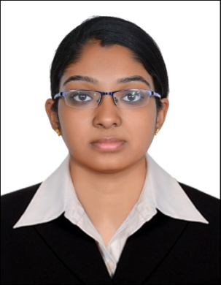
JEENA
Email: jeena.387973@2freemail.com

CAREER OBJECTIVE
- To obtain a position in which I can demonstrate quality customer service and employee satisfaction.
- To render my service and potential for the profit of the company and its success.
- To work in a stimulating and challenging environment to utilize and develop skills for career advancement and knowledge development.
EDUCATIONAL QUALIFICATION
SL NO | COURSE | NAME OF THE INSTITUTE | UNIVERSITY/ BOARD | YEAR OF PASSING | PERCENTAGE OBTAINED
1 | BACHELOR OF BUSINESS ADMINISTRATION | WISDOM BUSINESS SCHOOL,  RAS AL KHAIMAH, UAE | CALICUT UNIVERSITY | 2015 | CGPA=3.15
2 | SENIOR SECONDARY SCHOOL | ST.ANTONY'S HIGHER SECONDARY SCHOOL, KERALA,INDIA | BOARD OF HIGHER SECONDARY EXAMINATION,KERALA, INDIA | 2011 | 84%
3 | SECONDARY SCHOOL | ST.PATRICK'S SCHOOL, KERALA, INDIA | ICSE, INDIA | 2009 | 72%
EXPERIENCE
Worked as a trainee for six months in Technosteel Fabrication Company, Umm-Al-Quwain, UAE
CORE SKILLS
- Good interpersonal skill and negotiation skill
- Problem solving and decision making skill
- Flexibility and patience
- Organizing skills
- Multitasking skill
IT SKILL
- Microsoft Office Word
- Microsoft Excel
- Microsoft PowerPoint
- Internet Explorer
ACHIEVEMENTS
- Project done in Technosteel Fabrication Company, Umm-Al-Quwain, UAE
- Topper of the college during three years of BBA
- Best presenter award
- Good leadership award for coordinating activities
INTERESTS
- Finding and trying to implement new things
- Listening to music
LANGUAGES KNOWN
SL NO | LANGUAGE | READ | WRITE | SPEAK
1 | ENGLISH | YES | YES | YES
2 | ARABIC | YES | YES | AVERAGE
3 | HINDI | YES | YES | AVERAGE
4 | MALAYALAM | YES | YES | YES
PERSONAL DETAILS
Nationality : Indian
Date of Birth : 15/08/1993
Gender : Female
Marital Status : Married

