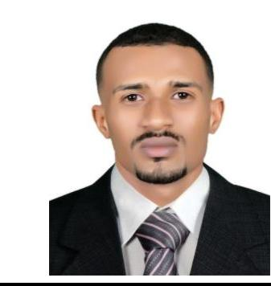

kamel
Email: kamel.388005@2freemail.com

PERSONNEL INFORMATION

Nationality:------------------------ | Sudan
Marital Stats:--------------------- | Single
Religon:---------------------------- | Muslim
languages:------------------------- | Arabic &English

Area of Expertise:

- Installation and service of medical equipments.

- Providing of technical support.

- Preparing and Presenting of technical reports .

- Problem solving.

- Risk Management.

- Communication skills.

Skills

-Good knowledge in general hospital department.
Good computer skills.

-Working in a team oriented environment.

Personal Profile

Disciplined biomedical engineer, with excellent communication skills. Organized and driven with innate ability to stay on task. Uses effective and efficient methods of engineering to solve current problems rising in the health care facilities and hospitals.

Education

[2010 – 2015] [B.Sc.(Honors) in biomedical engineering ] [University of science and technology]Sudan,Khartoum

Grade achieved: [Second Class _ devision two ]

Work Experience

    - Biomedical engineering at al_amal national hospital. [6th October 2015 – 6th October 2016] Sudan,Khartoum

- Control of medical equipment and make sure their performance as required.

- Repairing of medical equipment.

- Periodic and preventive maintenance of medical devices.

  - Biomedical engineering in Ministry of health in northern state. [13th September 2017 – 30th September 2018] Sudan,Dongula

- Installation, operation, maintenance and repair of medical device (OR and Laboratory equipment).

- Periodic maintenance.

- Writing reports for medical devices.
- Training in algam drugs and chemicals ,laboratory

department (Horiba equipment CBC). Sudan,Khartoum

