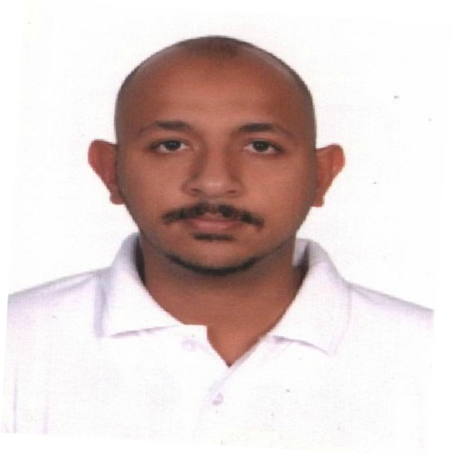CURRICULM VITAE

Name: WAEL
email: wael.388012@2freemail.com

OBJECTIVE
Iam seeking for a challenging career in a respective organization in order to gain experience. I will use this experience in order to develop a promising career path. I will apply all my abilities and skills with all my loyalty in a professional manner.

PROFESSIONAL SUMMARY

Motivated IT support technician seeks new position in dynamic, growth-oriented company focused on cultivating exceptional customer experience and a positive work environment. With experience handling networking concerns, implementing new software, installing new hardware, and addressing user concerns, I bring attention to detail and a dedication to technical improvement to each job. Past achievements include new network architecture component selection and implementation, earning leading industry certifications, and driving the achievement of departmental goals.

EDUCATIONAL QUALIFICATION

- Graduated from Omdurman Ahlia University 2011 as a Computer Engineer Sudan, Khartoum.
- Diploma in Basic LAN Network n+ (F-12 NETWORKS) 2012 India, Hyderabad

SKILLS

- Utilizing technical training to resolve concerns related to software functionality.
- Troubleshooting network concerns.
- Working in a team-oriented -environment.
- Providing phone and online support to users.
- Assisting users in person and remotely with hardware-related concerns.

WORK EXPERIENCE

IT SUPPORT Technician 9/11/2015 TO 31/07/2018
Leen Aamar Corporation Saudi Arabia (Riyadh)
- Installed and maintained company’s computer systems and network.
- Performed upgrades and installed updates.
- Completed troubleshooting and repair when computers had problems.
- Assisted office staff with computer application questions.
- Conducted computer technology training with all new staff.
- Recommended computer products and applications to improve productivity.

IT /customer service/call center 7/12/2013 TO 7/12/2014
Pasgianos food & beverage co. Sudan (Khartoum)

- Provided technical assistance to customers on inbound telephone tech support calls.
- Used remote access to perform troubleshooting when needed.
- Walked customers through step-by-step process for troubleshooting hardware issues.
- Assisted customers with anti-virus program installations and virus removals.
- Used good problem-solving skills for troubleshooting problems.
- Used great customer-service skills.

CERTIFICATIONS
- CCNA (Cisco Certifications Network) 2012 India, Hyderabad.
- Hardware/basic 2012 India, Hyderabad.
- Basic LAN Network n+ (F-12 NETWORKS) 2012 India, Hyderabad.

