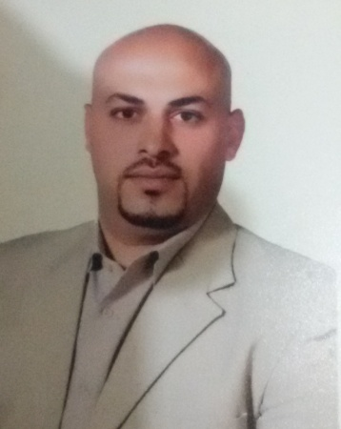
C. V
Name: Nahnoosh

Email: nahnoosh.388017@2freemail.com

Date and Place of Birth: 1984, Saudi Arabia
Nationality: Jordanian
Marital Status: Married

ACADEMIC QUALIFICATION
3RD engineer marine certificate
(Office in change of engineer watch).

Training Courses
-Proficiency in survival craft & rescue boats other than (F R B).
-Personal survival techniques.
-Personal safety & social responsible.
-Elementary first aid.
-Prevention & combating of marine pollution.
-Advanced firefighting.
-Ship Security Awareness

Languages
-Arabic: Mather language
-English: Excellent

Objective:
To pursue a career in a well-recognized organization to boost up my abilities in a challenging environment with commitment to hard work and encouragement for Innovation.
Professional experience:
Hijazi and ghosheh Livestock carrier
PANAMA APR.2017- jan.2018
I Worked with Hijazi and ghosheh as (3RD engineer) on the MVneameh ship Main Engine type Hitachi B&W (K45GF) power horse 5200BHP Auxiliary Engine type yanmar Diesel engine 6M(A)LC Prepares requisition for main engine & generator & auxiliary engine as special Tools & test equipment with manual
Performs preventative & demand maintenance on steam boilers. Maintains auxiliary boiler
Repair all pump type & pumping system maintenance, balance system, firefighting system, etc.
Given a good timing watch for engine room of the ship

Hijazi and ghosheh Livestock carrier
PANAMA JUN.2016-DEC.2016
I Worked with Hijazi and ghosheh as (Extra 3RD engineer) on the MVneameh ship Main Engine type Hitachi B&W (K45GF) power horse 5200BHP Auxiliary Engine type yanmar Diesel engine 6M(A)LC applied the quality control system for all machines. Improving & technical level
Auxiliary Diesel engine (over hulling), mechanical work.
Inspects work execution ensure that the quality of workmanship. Repair all pump type & repair all filter & all cooler type. Technical level of operator, Prepares requirement for materials
. & operator

Hijazi and ghosheh Livestock carrier
PANAMA JUN.2015-NOV.2015
I Worked with Hijazi and ghosheh as (4th engineer) on the MV dareen ship Main Engine type ulstein Bergen power horse 9600BHP applied the quality control system for, technical level of operator mechanical work, Repair all pump type & repair all filter & all cooler all machines, Good improving
Purifier (over hulling) & Air compressor

Hijazi & Ghosheh Livestock carrier
PANAMA JUN.2014-NOV.2014
I Worked with Hijazi and ghosheh as (4th engineer) on the MVneameh ship Main Engine type Hitachi B&W (K45GF) power horse 5200BHP Auxiliary Engine type yanmar Diesel engine 6M(A)LC Purifier type SJ2000, AIR Compressor typeSC25N, maintenance for main engine & generator. Repair all pump type & pumping system
Improving & technical level of operator. Maintenance of the Purifier

Hijazi and ghosheh Livestock carrier
PANAMA NOV.2013-APR.2014
. I Worked with Hijazi and ghosheh as (4th engineer) on the MVzein1 ship Main Engine type Hitachi B&W power horse 11400BHP Purifier type Mitsubishi & Air Compressor
Obtaining necessary safety & gate passes for equipment & machinery & procedures take action in case.
Prepares daily project reports & submit to the chief engineer. Maintenance of the Purifier
Applied the quality control system for all machines.

Heavy engineering industries & Shipbuilding CO. Ship yard OCT.2012 – AUG.2013
I Worked with HEISCO as mechanical engineer for
Diesel engine (over hulling), mechanical work.
Maintenance hydraulic system & hydraulic cylinder winches
. Repair all pump type & repair all filter & all cooler type. Technical level of operator. Prepares requisition for main engine & generator
& auxiliary engine as special Tools & test equipment with manual.

Arab Bridge Company Roro passenger
Jordan DEC 2010 – JUN. 2011
. . I Worked with Arab Bridge as (mechanical engineer) on the fb aylah ship Main Engine type wartsia power horse 7994BHP for applied the quality control system for all machines
Improving & technical level of operator. . Good operating mechanical.
Cleaning & dislodging of tank & miscellaneous work, painting machines works

Hijazi and ghosheh Livestock carrier
PANAMA AUG.2010 – DEC. 2010
. I Worked with Hijazi and ghosheh as (mechanical engineer) on the MVkenoz ship Main Engine type sulzer power horse 10200BHP for Monitor &Inspects work execution of machines in timing watch, prepares daily, good operating mechanical.

Mubarak Company Tug boat
UAE JAN.2010 - AUG.2010
I Worked with Mubarak as mechanical engineer for cleaning & dislodging of tank & miscellaneous work & painting machines works, test piping system & all tanks. Repair generators as required
Diesel engine (over hull), mechanical work in work shop. Formulate schedules organizes personnel & project execution of the works. Maintenance all type of the valves

