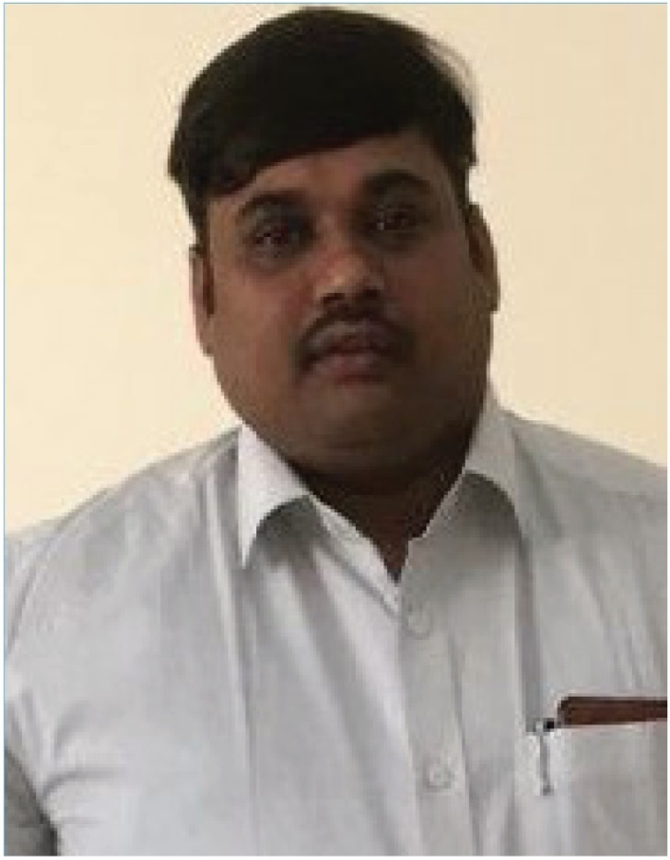
PRASAD

Email: Prasad.388026@2freemail.com

Oracle Fusion Financials Implementation &
Senior Accountant
Summary
- Around Eight years of experience in Accounting in Manufacturing Industry with rich experience in taking care of all day-to-day accounting activity with sound knowledge of Taxation and finalization financials (Balance Sheet & P&L finalization In Tally).

2016-04 -
2018-10
Oracle Fusion financial cloud ( AP, AR, GL, 02C, P2P, Fixed Assets And others Reports)

·Sound Knowledge of Tally ERP software Latest Version Tally ERP-9 Latest 4.6.7 And Oracle fusion financials around six months ( AP, AR,02P, P2P and Assets Management)
- Sound Knowledge of MS office, MS Excel and Internet
- Knowledge of Good & Services Tax,
- Sound Knowledge of Statutory Compliance( VAT, Excise, Customs, Services tax, PT, ESI And PF)
- Sound Knowledge of AR And AP ( Receivables and payable)
- Sound Knowledge of Sales Tax, Excise duty, Customs duty, Services tax and TDS.
- Sound Knowledge of General Accounts, Balance sheet & P&L A/c (Finalization of financial statement)

Experience

Senior Accountant (4th April 2016 to 05th October 2018)
SANPAR Microfilters. Pvt. Ltd - Accounts Dept.
·Verification All entry's related to Sales, Purchase ,Journals and month end accounting entry's
  - Good & Services Tax workings returns filing varies methods (GSTR-1,GSTR-3B & GSTS-2A Reconciliation with books.)
  - Salary preparation & Disbursement salary monthly basis.
  - Workings for All Statuary's Monthly & quarterly Yearly basses in Excel & comparison to tally date (Exim : VAT, PT, Excise, PF, ESI and TDS )
  - Monthly MIS Report towards Expenses & Revenues to Management.
·To Attend the Sales tax Assessments & other statuary complaints. (SMPL I am attend the sales tax assessment s for the financial year 2012-13 & 2013-14,2014
-15& 2015-16 ) & sister consonants company SIPL for 04 years ( 2010 to 2014&2015-16 )
  - Preparing cash flow statement of weekly basses.
·To attend the yearly financial audit from our company audit (clarifying the audit observations)
  - Preparation of yearly ending closing entry's ( Expo Provision & prepaid expenses & Others Expenses )
  - To Finalization of financial statement (Balance sheet & Profit & Lass A/c )
  - Proportion of employee income tax computation for the year,
  - To filing of the VAT 240 & ROC as per the tax audit requirement.

Personal Info

Date of birth
1987.12.31

Skills
Tally ERP. New Version
•••••
Ms. World, MS. Excel in Advanced.
•••••
Oracle Fusion Financial Cloud( GL .
AP,AR,02C,P2P and others )
•••••
Financial Reports Like Balance Sheet
And Profit Lass Account in Tally
•••••
Cash Flow statement And Reports
•••••
AP, AR, GL in Tally ERP
•••••

2014-04 -
2016-04

2012-1 0 -
2014-04
- Senior Accountant (April 2014 to April 2016)
KNND Associates Pvt. Ltd-Accounts Dept.
  - Responsible to handle of Bank Reconciliation statements
  - Maintaining Annexure 10 & Central Excise Returns Workings
  - Maintaining Purchase & Salas Entry's
  - Maintaining of Purchase Order
  - Maintaining of Salas Tax Calculation & Excise calculation
  - Updating day- to- day transactions
·Verification of invoices, Vouchers, Ledger
  - Statement of Bills Receivable and Bills Payable
  - Filling for Vat100, Central Excise ER1 & ST3, PT
  - Raising DC & Invoices
  - TDS, STAFF IT, CENTRAL EXCISE DUTY, VAT, PT, Payment made within due dates using online payment
- Senior Executive- Accounts (October 2012 to April 2014)

Micrologic Integrated Systems Pvt. Ltd - Accounts Dept.
  - Compile and analyze financial information to prepare entries to accounts, such as general ledger accounts, and document business transactions
  - Responsible to handle of Bank Reconciliation statements
  - Maintaining Annexure 10 & Central Excise Returns Workings
  - Maintaining Purchase & Salas Entry's
  - Maintaining of Purchase Order & Bank Reconciliation
  - Maintaining of Salas Tax Calculation
  - Updating day- to- day transactions
·Verification of invoices, Vouchers, Ledger
  - Statement of Bills Receivable and Bills Payable
  - Raising DC & Invoices
  - Handling Petty cash
LC (Letter of Credit ), BG(Bank Guarantee) and TT. Payment's And
other Documents preparation
•••••
Revenue & Expenses Reports
•••••
VAT,(Filing online Workings Monthly
Basis)
•••••
GST, (Filing Online GSTR-1, GSTR-3B
and Payments’ monthly Basis)
•••••
Stock Statement Preparation Monthly
Basis
•••••
TDS (Monthly payment & Qtr'ly filing
Preparation)
•••••
Software
Oracle Fusion Financial Cloud
•••••
Tally ERP Software New Version
•••••

2010-08 -
2012-09
  - Maintain all Inventory's in monthly basis and Preparing Monthly Vat Returns file

Accounts Assistant (August 2010 to September 2012)

SA Engineering Works India (P) Ltd.- Accounts Dept
  - Maintaining of Petty Cash Entry, Bank Entry's
  - Maintaining Purchase & Salas Entry's
  - Maintaining of Purchase Order & Bank Reconciliation.
  - Maintaining Annexure 10 & Central Excise Returns Workings
  - Maintaining of Salas Tax Calculation
Ms. World & MS Excel

Languages
English

Kannada
•••••

•••••
•••••

2007-01 -
2010-08

2005-01 -
2007-01

2005-01
Education Telugu

Bangalore University, Karnataka
B.Com (Bachelor Degree in Commerce) Tamil

SSEA Govt. PU College, Gowribidanur
Hindi
PUC (Pre University in Commerce)

Govt. School, Kadalveni
SSLC (Secondary School Leaving Certificate)

•••••
•••••
•••••

