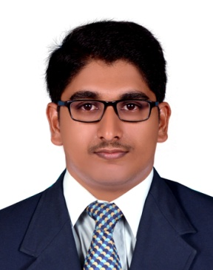

Email: shafee.388042@2freemail.com

SHAFEE

CAREER OBJECTIVES

Intend to build a career with leading corporate of hi-tech environment with committed & dedicated people. To explore myself fully and realize my potential with the best minds in the industry. Willing to work as key player in a challenging and creative environment.

EDUCATION & OTHER COURSES

COURSES | SCHOOL/  COLLEGE | UNIVERSITY/  BOARD | YEAR OF PASSING | CGPA/  GRADE | PERCENTAGE
Bachelor of Technology in Mechanical Engineering | Rajiv Gandhi Institute of Technology, Kottayam | MG University, Kottayam | 2018 | 6.93/10  (First Class) | -
Diploma in Building Mechanical System | MEDAC Design Academy | MEDAC Management and Academic Council | 2018 | A Grade | -
Higher Secondary | Nochat Higher Secondary School, Nochat | Kerala State | 2013 | - | 88.66
SSLC | Nochat Higher Secondary School, Nochat | Kerala State | 2011 | - | 98

TECHNICAL SKILLS

- Operating Systems : Windows 8/7, Linux

- CAD/CAM Softwares : CATIA v5, Auto CAD

- Programming Languages : C, C++

                - Other Softwares : MS Word, Excel, Power Ponit, Carrier HAP, Elite Duct Size,
McQuay Pipe Sizer and Duct Sizer
ACHIEVEMENTS & AWARDS

- Secured 2970th rank in Kerala Engineering Entrance Exam in 2014
- Awarded Merit Cum Means Scholarship
TECHNICAL AND INDUSTRIAL EXPERIENCE

- Project on ‘Employability Gap of Engineering Graduates in RIT’ to understand the employability gap among the engineering graduates of Rajiv Gandhi Institute of Technology, Kottayam.
- Seminar on ‘Fundamental Theories and Key Technologies for smart and Optimal Manufacturing in the Process industry’

- Attended a 5-day training programme in Kozhikode Diesel Power Plant. Studied about various sections in a diesel power plant, engine components and various different systems in the plant.

- One-day visit at Autocast, Cherthala introduced us to all procedures of industrial casting. Studied various technologies used in casting.

INTERESTS & HOBBIES

- Watching movies

- Driving

- Social service

LANGUAGES KNOWN

- English -Speak, Read, Write & Understand.

- Malayalam -Speak, Read, Write & Understand.
- Hindi(Basic)

PERSONAL DETAILS

Date of Birth | : | 05 MAY 1996
Gender | : | Male
Nationality | : | Indian
Civil Status | : | Single

