CURRICULUM VITAE

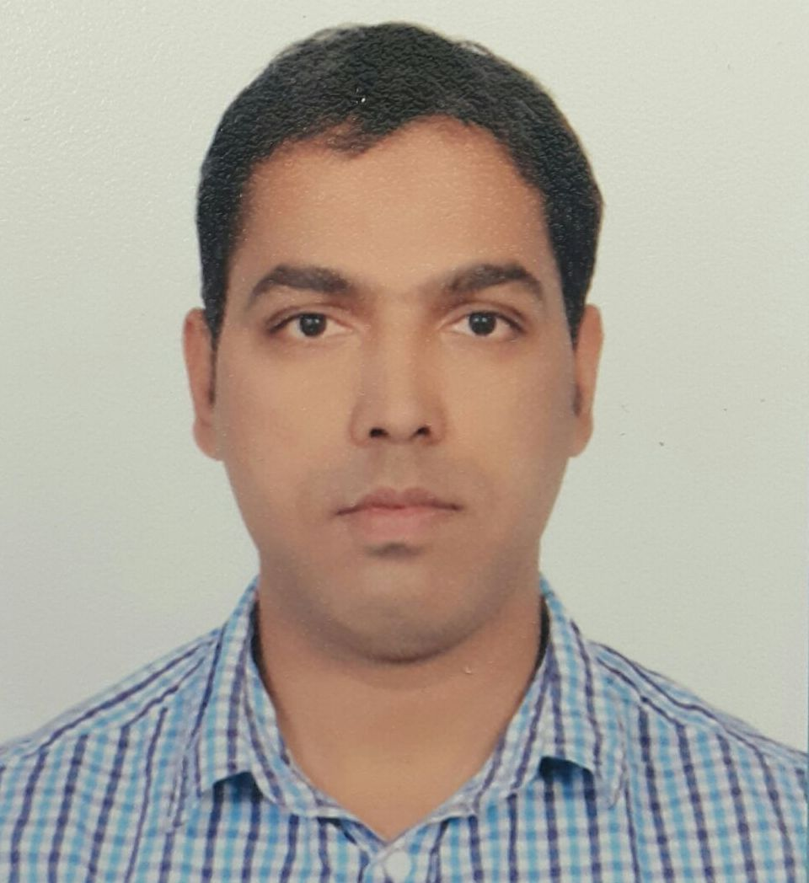
AHMAR
Email. Ahmar.388088@freemail.com

OBJECTIVE:

To seek position that will utilize my skill,abilities,desire for learning and commitment to success and to work with dedication and honor in accordance with the highest standards of professional practice.
MOH LICENCE EXAM ( KUWAIT )

- I have also appeared for MOH license exam (Kuwait) and have successfully achieved the license to work.

DHA (DUBAI HEALTH AUTHORITY ) LICENSE

DATA FLOW BARCODE (DHA) – D001-1810-288177
DHA Eligibility Letter Reference Number - DHA/LS/2782018/839862

WORK EXPERIENCE
Total Experience : 13 years

- Presently working as a lab technician in Kuwait cancer control center (KCCC) pathology cytogenetics & molecular cytogenetics, Hematology, Blood Bank, laboratory under MOH Kuwait since 26 October 2014 to till date.
- Worked as laboratory technician in Aerobiology department since 21 November 2013 to 25 October 2014.
- Worked as a Senior Scientific Officer in NABL & NABH accredited lab Max super Speciality Hospital (800 Bedded multi &super specialty hospital) press enclave road,saket New Delhi since 20thJune 2006 to31 October 2013.
- Worked as a Technician in NABL & NABH accredited lab Moolchand Medcity Hospital & Research Centre, New Delhi from 25th sep. 2004 to 19th may 2006.
- Worked as a Technician in Dr.Makashir Lab Vikram Vihar, New Delhi (An ISO9001: 2000 Certified Laboratory) sep 2003 to sep 2004.

- Worked as Training Technician with Sita Ram Bhartiya institute of science and research institute,(SBSIR) New Delhi. 15 Dec 2002 to 15 June 2003.

JOB RESPONSIBILITIES:

- Processing and analyzing QC Materials.
- Maintaining all documents for NABL / EQAS.
- Handling queries from patients / client services / clinicians etc.
- Knowledge Of Hospital Management System.[ HMS]
- Knowledge of National Accreditation Board for Hospital and Healthcare Providers.
- Monitoring quality via internal proficiency testing (Split samples and normal samples).
- All quality management trouble shooting with instrument and reagent to rectify the problem.
- Maintain quality control according to the NABL recommendation.
- Help in preparation of internal and external audit.
- Assist quality manager to maintain overall quality in laboratory preparation.

Instruments Handled during my work
- Have worked with fully automated organizations.

BIOCHEMISTRY ANALYZERS

- RA-50 [Semi-Automated Analyzer]

- Beckman (sysnchron clinical system CX5
- HITACHI-912 -[For chemistry Analysys ]
- HITACHI -717-[ For Chemistry Analysys ] Beckman [synchron clinical CX4 USA]
- Micromat Investigation for Glycosylated Hemoglobin-[Bio-Rad-II]

HAEMATOLOGY ANALYZERS
- Sysmex K-4500-[Fully Automated Japan]
- Sysmex-3000- [Fully Automated Japan]
- VesMatic-20- [For Esr Investigation] Sysmex
- kx-21- [18 parameter Analyzer]
- Beckman Coulter 750
- Beckman Coulter HMX
- Beckman Coulter DXH 600
- Beckman Coulter DXH 800

COAGULATION ANALYZER
- ACL TOP 500
- ACL TOP 300
- ACL Advance
- ACL Elite Pro

MICROBIOLOGY & SEROLOGY
- Blood Culture – Bactec 9050 / 2010
- BacT Alert for Blood Culture

ROUTINE CLINICAL PATHOLOGY TEST

Urine Routine / Microscopic Examinations. (CLINISTAT, CLINITEK 500)

Note:- Have experience of working in Departments such as cancer Genetics,Hematology,Biochemistry,immunology,Blood Bank,Microbiology,Clinical Pathology & Serology.
I have also worked with NABL accreditation & CAP accreditation under the supervision of my senior during my work experience.

PROFESSIONAL QUALIFICATION
- 2007-2010–B.Sc. MLT
Institute of Para Medical Technology.
Vinayka Mission University
Salem, Tamilnadu,
- 2001-2003 -DMLT
Institute of Public Health and Hygiene (IPH&H),
Mahipal Pur New Delhi

EDUCATIONAL QUALIFICATION
- 10th passed from Bihar Board in 1999 with 1st division.
- 12th passed from Bihar intermediate Board in 2001 with 1st division.

COMPUTER KNOWLEDGE
- Adequate knowledge of basics:- Microsoft word, Excel, Power point, Windows, Internet etc.
PERSONAL INFORMATION:

Date of Birth | : | 1st January 1984
Gender | : | Male
Marital Status | : | Married
Languages Known | : | English ,Urdu, Hindi
Hobbies | : | Singing, Reading, Cricket, Football, etc.
Nationality | : | Indian

