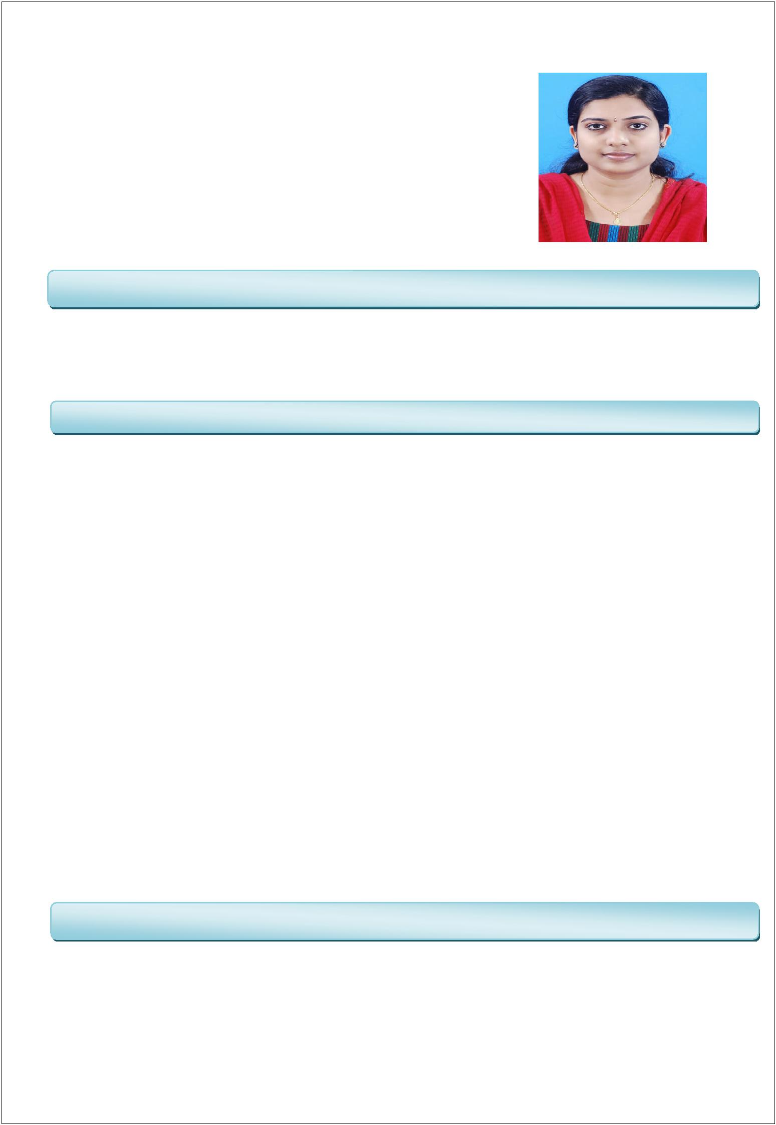

SARIGA

Email: sariga.388089@2freemail.com

CARRIER OBJECTIVE

To pursue a challenging position in a progressing and dynamic organization that allows me to apply and enhance my knowledge and recognize my contribution to the growth of organization.

Q test Solutions Pvt Ltd, Calicut

Designation: - Software Tester
Duration : - July 2016 to August 2018

To read all the documents and understand what needs to be tested.

Based on the information procured in the above step decide how it is to be tested. Inform the test lead about what all resources will be required for software testing. Develop test cases and prioritize testing activities.

Execute all the test case and report defects, define severity and priority for each defect.

Carry out regression testing every time when changes are made to the code to fix defects. On Demand HRM.Com
Designation: - Apprentice Software Programmer
Duration : - Feb 2016 to June 2016

Designed web sites, test or modify design to meet client engineering demands. Led software programming, documentation and instruction creation.

Kept clients informed about software system design and gave support.

Examined user requirement to determine usability of design according to time and cost objectives.
EDUCATION

B TECH in computer science and Engineering under CUSAT University with First class (2011-2015).

12th from GVHSS Payyoli, Kozhikode , kerala with an aggregate of 76%. 10th from CKGMHS Chingapuram, Kerala with an aggregate of 95%.

Main Project: AIVOS (Artificially Intelligent Voiced Operating System)

▪ A new operating system which is artificially intelligent and voice controlled.

▪ It is the most unique operating system based on the need for a new interaction with the ▪ computer.

Technology: C, Java, Eclipse, NLP etc.

Mini Project: SIMPLOIDE (A Voice Activated Social Networking Site)
▪ A social networking site that can be controlled by voice.

▪ Technology: PHP, MySQL , HTML.

Technical skills: C, C++, Java, HTML, PHP, MySQL, CSS.

Operating system known: Windows, Ubuntu, Mac.

Areas of interest: App Development, Software Development, Website designing.

Computer Application : MS-Office (Word, Excel, PowerPoint).

Ethical hacking expert conducted by Tech Defence Pvt Ltd. Ahmedabad at College of engineering Vadakara for 2 days on 2012.

Training programme in Java,PHP and Web designing by Career planters Solution Ltd for 5 days on Nov 2013.

National Level Web development workshop by i Pruner for 1 day on 2013. Windows 8 APP Development and Training by KNAP for 2 days on Jan 2014. Java Development and Training by HCL for 6 days on June 2014.

To work for my career growth and better prospects which contribute to the Productivity and Profitability of the Organisation.
Detail oriented with an analytical bent of mind and possess positive attitude. Willingness to Learn and Work Hard, Adaptable.
Highly motivated and Energetic, Self-starter, Leadership qualities, Open to ideas and Quick Learning ability.
Ready to work in a Challenging Environment.

Name | : | Sariga
Date of Birth | : | 31/03/1993
Sex | : | Female
Marital Status | : | Married
Nationality | : | Indian
Linguistic Abilities | : | English,Hindi and Malayalam

