RACHELLE
Email: rachelle.388100@2freemail.com

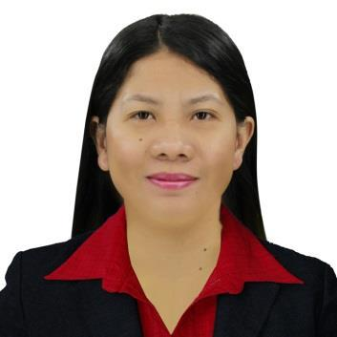

Objectives: To obtain employment with a company that offers a positive atmosphere to learn and implement new skills and technologies for the betterment of the organization.

SKILLS AND ABILITIES:
- Operating MS office tools. (Microsoft Word, Microsoft Excel, Microsoft PowerPoint)
- Knowledgeable in Adobe Photoshop
- Can do Multitasking
- Ability to finish reports ahead of time.

WORK EXPERIENCE:

DOCUMENT CONTROLLER/ACCOUNTS CONTROLLER May 31, 2011 – Dec 04, 2018
Honda Motor Sports Inc./Superbikes Center
Nalsian, Calasiao, Pangasinan
From Cashier to Data Controller (Promoted)

Duties and Responsibilities
- Encode Daily Transactions in store system
- Responsible for office files
- Invoicing of Motorcycle releases
- Creating Purchase Order for Motorcycle and Accessories/Follow up Purchase order

- Checking and Receiving of Motorcycle Deliveries from Cargo and Encode it in the system

- Monitoring of Motorcycle Sales & Inventories.
- Preparing of Daily, Weekly and Monthly Reports and submit to Head Office
- Monitoring of Store Inventory(Motorcycle and Accessories)
- Weekly Auditing of Petty Cash Fund
- Entertain Client’s Concern and giving them a good service
- Monitoring of Accountable Receipts
- Preparing Daily and Weekly Store Daily time Record and submit to Head Office(HR)
- Accepting calls from clients and from Head Office
- Updating/Recording of Customer Ledgers
- Performing the task of Store Manager, Cashier and receptionist.
- Preparing Cash & Check vouchers
- Liquidating of Cash Advance Fund (PCF, Marketing Budget, etc.)
- Selling Motorcycle units
- Daily Updating of Book Of Sales
- Creating of Ledgers for new Accounts
- Monitoring and Recording of Account’s monthly payment

- Responsible for Incoming, Outgoing Calls and also Emails.

BRANCH CASHIER/COORDINATOR Dec 01, 2010 – May 15, 2011

Exponent Motor Corporation
271 Cacamilingan Sur, Camiling Tarlac
Duties and Responsibilities
- Collect and Encode Daily Transactions to system

- Issue Receipts, Sales Invoice and etc.
- Checking and Receiving of MC Deliveries

- Monitoring of Inventory
- Montoring of Petty Cash Fund
- Daily Updating of Book of Sales
- Monitoring of Accountable receipts
- Entertain Customer’s concern and give a good service

CUSTOMER CARE STAFF January 2010 – May 2010 V-Tech Barcode Systems Philippines Inc.

Unit 205 The Tower at Emerald Square Bldg., Quezon City Duties and Responsibilities
- Assisting Customer’s concern
- Printing of Barcode and checking the error (Quality Control)
- Answer Phone Calls and divert to designated department
- Act as receptionist

PERSONAL INFORMATION:

Age: 30 years old
Date of Birth: April 21, 1988
Place of Birth: Pangasinan Provincial Hospital
Gender: Female
Status: Single
Citizenship: Filipino
Religious Affiliation: Roman Catholic
Educational Attainment: College Graduate
Course: Bachelor of Science in Information Technology

EDUCATIONAL BACKGROUND:

TERTIARY:

SECONDARY:

ELEMENTARY:

Bachelor of Science in Information Technology
University of Pangasinan
Arellano St., Dagupan City
2005-2009
Bued National High School
Bued, Calasiao, Pangasinan
2001-2005
Quesban, Elementary, School

Quesban, Calasiao, Pangasinan
1995-2001

