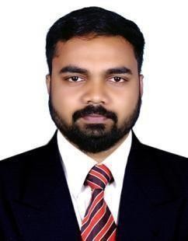
JINEESH

Email: jineesh.388106@2freemail.com

Visit visa till March 12, 2019 Dubai

PERSONAL PROFILE

A Master of Business Administration (MBA) graduates from University of Bedfordshire, United Kingdom. During my master’s I positively combined my studies with work and other commitments showing myself to be self-motivated, organized and capable of working under pressure.
I have acquired skills and knowledge essential for managing key areas in an organization, enjoy working
in my own initiative as well as in a group. I try to learn something new from every experience because I believe there is always room for self-improvement both personally and
professionally.

WORK EXPERIENCE

2016-2018 – Sales and Marketing Executive at RAAF Kerala, India
- Conducting weekly Business Development meeting with the team.
- Conduct market research and identify new opportunities.
- Create new promotional strategies to increase the overall business.
- Bring in new innovative ideas to lead the market.
- Managing social media promotion activities.
- Daily Reporting to the Director.

2014-2016 – Sales and Marketing Executive at Aqua Business Consultant Ltd, UK
- Building business relationship with current and potential clients.
- Identifying, qualifying, and securing business opportunities.
- Answering and responding to client’s questions and proposals.
- Making multiple outbound calls to potential clients.
- Demonstrates the services to the clients.
- Schedule the appointments and meetings as necessary.
- Researches client base to find new types of customers and sells to them accordingly.

EDUCATION AND QUALIFICATION

- MBA in Finance in the year of 2016 from University of Bedfordshire, United Kingdom.
- BCom the year of 2011 from Periyar University, India.
- Higher secondary education done in the year 2006.
- Diploma in Restaurant Management in the year of 2007 from Ministry of HRD India.

SKILLS
Time management, Problem handling skills, Organization and management skills, improved team working, ability to priorities my workload under pressure, Strong management and organizational skills.

PROJECT

Dissertation: Measuring post-merger and acquisition financial performance of TATA and Jaguar Land Rover UK.

ACHEIVEMENTS

- Won first prize in teaching presentation in the first practice week during the MBA course at the University of Bedfordshire.
- Won second prize in consultancy project presentation in the second practice week during the MBA course at the University of Bedfordshire.
- Won first prize in airline simulation in the fourth practice week during the MBA course at the University of Bedfordshire.

PERSONAL INFORMATION

Name : Jineesh

Date of Birth : 07/11/1988

Gender : Male

