SURENDRAN
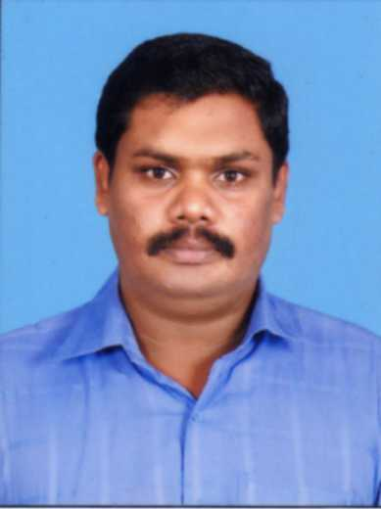

Email: surendran.388116@2freemail.com

Professional Objective

Secure a challenging position in a reputed institution where I can effectively contribute my skills as a technical professional and to enable value addition to self and the organization.
Educational Profile

Qualifications | Institution | Board /  University | Year of passing | Percentage of marks
Diploma  Mechanical Egg. | Surya Polytechnic College, Nagercoil | Tamil Nadu | April 2009 | 76.63 %
Higher Secondary  Computer Science | NRPM HSS Kayamkulam | Kerala | March 2005 | 55.5 %
10th standard | K H S, Puthiyavila | Kerala | March 2003 | 60 %

Working Experience

(1) Company Name | UBDACE ITC, Kayamkulam, Kerala.
Designation | Instructor.
Responsibilities | Teaches the Machine Drawing subjects.
Period | 1st April 2009 -10th May 2010.

(2) Company Name | TATA Motors, Pimpri, Pune.
Designation | Inspector.
Responsibilities | To check the vehicle and detect defects in it (QA Auditor).
Period | 6th March 2011 – 24th October 2011.

(3) Company Name | Arunachal State Transport Service (ASTS)
Designation | Technical Apprentice
Responsibilities | Repairing and Maintenance of Heavy Vehicles
Period | November, 2011 To 21st November, 2013

(4) Company Name | T.K. Engineering Consorting Pvt. Ltd.
Designation | Mechanical Engineer
Responsibilities | Maintenance of Heavy Vehicle, Heavy Equipments and Plants
Period | Since December 2013 to October 2015.

(5) Company Name | UNIBETON READY MIX
Designation | Store Keeper
Responsibilities | Inventory management of mechanical store.
Period | Since December 2016 to Present

Technical Knowledge

- Non Destructive Testing (Level II )
Computer Knowledge

- Diploma In Mechanical CADD (Auto CADD + Pro E)
- MS-Office
- Internet
Participations and Membership

- Member in YMCA Association.
- Participated in MalayalaManorama’s all Kerala Balajanasakyam.
- Sport wing secretary in Pourasamithi in our village.
Achievements

- Attended a national level seminar conducted by Tamil Nadu State.
- Attended a training program conducted by Tamil Nadu State Transport Corporation.

Abilities

- Confident and hard working
- Good leadership quality
- Ability to mingle freely with others
- Positive attitude and team spirit

Personal Details

Age/DOB : 29 yrs. /15-05-1988
Sex : Male
Marital Status : Single
Religion : Hindu
Nationality : Indian
Languages Known : English, Malayalam, Tamil, and Hindi.
Hobbies : Listening to music, Travelling.

