ANA

F&B Outlet Manager - WORK HISTORY
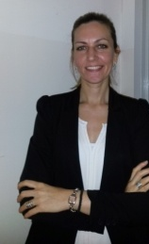
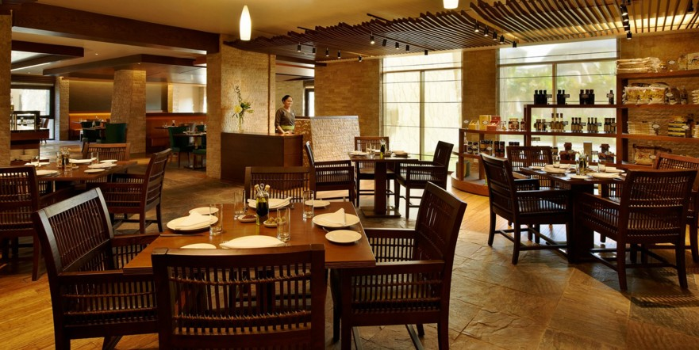
Date of birth: 30.06.1978.

Email: ana.388131@2freemail.com

PROFESSIONAL OBJECTIVE
I truly believe that nothing significant can be achieved without integrity, innovation, people focus and commitment. I am resilient and I not only take all ups and downs in my stride but also learn from them, as I continuously move towards my goals.
Effectively discharge the roles of a strategic partner in business, an employee champion, and an expert by shifting functional focus from what “I DO" to "What I deliver".

WORK EXPERIENCE (17 years):

17/11/2016-3/12/2018: Sofitel The Palm Hotel, Dubai, United Arab Emirates (2 years)

Role:

03/12/2017 – 3/12/2018 - Outlet Manager, Moana – A signature Seafood Restaurant - Fine Dining - 1 year
- Being in charge of a team of 14 employees

24/04/2017 – 2/12/2017 - Outlet Manager, The World Eatery Restaurant – An international cuisine ADD restaurant) - 7 months
- Being in charge of a team of 24 employees
- Being in charge for closing the Bottega restaurant for the refurbishment and reopening of the new
The World Eatery restaurant
- Oversee the daily operations of outlet for efficient operations
- Develop and enforce established policies and procedures
- Agreeing and managing budgets
- Ensuring compliance with licensing, hygiene and health and safety legislation/guidelines
- Establish operational strategies to meet quality and customer service standards
- Develop marketing strategies to improve sales and profitability
- Interview and hire associates for outlet operations
- Schedule orientations and job trainings to outlet associates

17/11/2016-23/04/2017 - Assistant Outlet Manager, Moana – A signature Seafood Restaurant - 5 Months
- Ensuring management continuity in absence of the Restaurant Manager
- Setting prices, Monitoring profitability and performances in order to meet targets
- Set-up event (party, live music, etc.)
- Train and coach staff on Standard of Good Practices
- Ensuring the H&S and Sanitary practices are being respected and met.
- Handling staff training, performances and reviews
- Monitor and maintain the Micros POS System
- Assist in new menu implementation

08/06/2014-19/06/2016: Jumeirah Restaurant Group, Dubai, United Arab Emirates (2 years)

Role: Assistant Restaurant and Bar Manager, Alta Badia Restaurant & Bar, Emirates Towers
- In charge of the entire Bar operation and assisting the Restaurant Manager
- Ensuring Local Authority Regulations are met
- Set-up event (party, live music, etc.)
- Handling Social Media updates
- Setting prices, Monitoring profitability and performances in order to meet targets
- Stock checks and placing orders with suppliers
- Handling staff training, performances and reviews
- Ensuring the H&S and Sanitary practices are being respected and met.

20/11/2012-20/01/2014: One & Only Royal Mirage Hotel, Dubai, United Arab Emirates (1 year, 3 months)

Role: Assistant Restaurant and Bar Manager, Nina Restaurant and Rooftop Terrace Bar
- Overseeing and managing all areas of the Restaurant & Bar
- Responsible for ensuring that all financial and personnel/payroll related administrative duties are completed accurately and on time
- Ensuring the H&S and Sanitary practices are being respected and met.
- Daily scheduling, planning while upholding standards, product quality
- Develop employees by providing ongoing feedback, establishing performance
expectations and by conducting performance reviews.

22/12/2009-13/10/2012: Al Tayer Group, Bloomingdale’s, Dubai, United Arab Emirates (2 years, 10 months)

Role: Pre opening team - Supervisor (Senior Sales/Brand Specialist)–Department store
- Achieving individual, departmental and store sales targets
- Identifying customer needs and delivering excellent customer service
- Providing trainings and updates about the brands to the team
- Train staff

19/01/2008-13/12/2009: Jumeirah International LLC, Dubai, United Arab Emirates (1 years, 11 months)

Role: Hostess Supervisor/Restaurant Reservations, Jambase Supper Club, Madinat Jumeirah
- Support the Jumeirah Quality Management System
- Maintain working knowledge and follow all departmental SOP’s
- Maintain an effective reservation system and ensure all client’s needs are met
- Ensure establishment targets are met
- Ensure all administrational work is up to date

01/02/2007-18/01/2008: Jumeirah International LLC, Dubai, United Arab Emirates (11 months)

Role: Team leader, Bahri Bar, Mina a Salam Hotel, Madinat Jumeirah
- Ensuring the standard procedures are being followed
- Make sure all departmental KPI’s are met

01/04/2001-10/01/2007: Private business “Tatarski”, Irig, Serbia (5 Years and 9 months)

Role: Assistant Store Manager
- Organising sales targets
- Handling all incoming and outgoing stocks in the shop
- Monitoring products stock
- Conducting monthly evaluation off staff
- Trainings new staff

EDUCATION - TRAININGS - SKILLS

Education

09/1996-06/1998 Law University, Novi Sad Serbia
2 years completed. Passed Roman law, Inheritance law, History–national and world

Training

PIC, Basic Food Hygiene, HACCP Certificate, P&L, Fire and Safety, First Aid training, Assistant to project manager in F&B office in Al Qasr for 6 months, Attended front office cross training at Al Qasr Hotel for 4 months, Certificate for F&B Secretary cross training in Mina a Salam Hotel, Train the trainer

Languages Skills

English (fluent), Russian (basic), Serbian (mother language)

Computer Skills

Microsoft Office, Epicure training, Micros training

