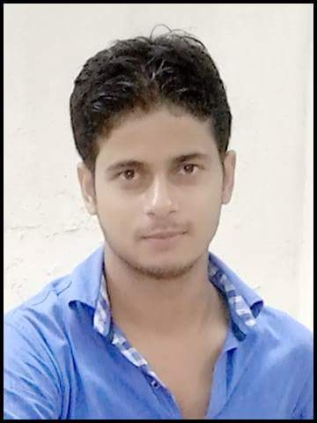
CURRICULUM VITAE

Yaqub

Email: yaqub.388137@2freemail.com

______________________________________________________________________

OBJECTIVE:

Looking for a challenging and demanding position in Construction(Residential & Commercial) commissioning in a growth oriented organizations where there is an ample scope for individual and organizational growth.
A dedicated Civil Engineer skilled in all phases of engineering operations. Consistently finishes projects under budget and ahead of schedule. Forward thinking professional familiar with all aspects of construction of commercial and residential planning. Advocates for sustainable infrastructure.

WORK EXPERIENCE:

- 4.5 Years of experience as Site & Design Engineer (Sameer Construction. Lucknow,Uttarpradesh).

CIVIL ENGINEER JOB RESPONSIBILITIES:

- All the line level.
- All the layout as per drawings.
- All the types of safety care taker.
- Site supervision of all construction works..
- Ensure smooth commissioning of the projects.
- Responsible for Preparation of Bill of Quantity of Materials for Projects.
- Estimation & costing the projects.
- Project management, Erosion and sedimentation control.
- Operational analysis, Land development planning.
- Technical plan execution, Strong technical aptitude.
- Complex problem solver, Clinical thinker..

ACADEMIC PROFILE:

BACHELOR OF TECHNOLOGY IN CIVIL ENGINEERING securing 70% marks from UPTU University, LUCKNOW, INDIA.

TECHNICAL SKILLS:

Design,Drafting(AutoCAD) Erection, Supervision, Commissioning of civil projects.

COMPUTING & SOFTWARE:Microsoft-Office 2010, AUTOCAD Drafting, MS EXCEL.

CODES & STANDARDS:IS 456.

Projects Handled:

- Golden Blossom Hotel & Resorts (Lucknow,Uttar Pradesh).
- RESIDENTIAL VILLA (Highland tower & Villas, Red Homes, Lucknow).
- Varun Baverages Ltd (UPSIDC phase 2, Sandila ,Hardoi.)
- Government projects (Finance commission building).

PERSONAL SKILL

- Self-motivated.
- Quick learning skill.
- Ability to adapt any environment or situation.
- I have the ability to cope with failures & try to learn from my mistakes.

PERSONAL PROFILE:

Name : YAQUB AHMAD
Gender : MALE
Date of Birth : 08/08/1992
Religion : MUSLIM
Nationality : INDIAN
Marital Status : UNMARRIED
Languages : ENGLISH,HINDI, URDU.

