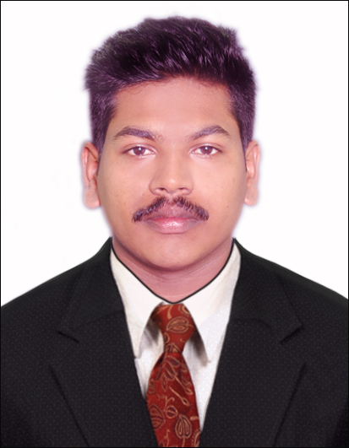
ARUN
Email id: arun.388171@2freemail.com
PROFILE SUMMARY
Young and dynamic Civil Engineer project management skill seeking a solid carrier foundation to develop capabilities. With past experience and future intend to continue a fiduciary duty with various stakeholders and providing high level of competence.
SYNOPSIS
- Astute and versatile Civil Engineer offering Two years of experience in Engineer sector as SITE SUPERVISOR.
- Skilled in critical thinking, communicating and technical skills and project management.
- Organizing. Drafting and documenting the technical documents.
- Expertise in data collection and supervising construction work
CAREER HISTORY
DEPCON VENTURES PVT LTD Ayyanthole, Thrissur, Kerala as a site supervisor since Oct 2017 to till Nov 2018.
SAHASRA CONTRACTORS, Kannara,Thrissur, Kerala as a site supervisor since Nov 2015 to till Nov 2016.

ROLE AND RESPONSIBILITIES

- Setting out Project work in accordance with Drawings and specification.
- Preparing record, Technical reports, Site Diary, Time lines, Reviewing Drawing, Material approval, bar bending schedule and Procurement management.
- Well versed with the different stage of building construction from excavation of finishing.
- Read and understand Engineering Drawing and Execute construction plan at site also analyzing survey, mapping & material testing.
- Ensuring project run smoothly and structures are completed within budget and on time.
- Weekly and monthly progress report presentation.
- Prepare weekly and monthly target per schedule.

EDUCATIONAL QUALIFICATION
- Having Professional in building design DIPLOMA with
CADD CENTRE, Thrissur,Kerala,India 2016 to 2017

- Diploma in Civil Engineering with RAJA REDDY INSTITTUTE OF
POLYTECHNIC Bangalore, Karnataka, India 2012 to 2015

SKILLS AND EXPERTISE
- Expert in use of Auto Cad Software.
- 3Ds Max
- Microsoft Office Word
- Microsoft Office Excel
- MS Power point

LANGUAGES KNOWN
Particulars | Writing | Reading | Speaking
English
Hindi
Tamil | - | -
Malayalam

PERSONAL DETAILS
Nationality : Indian
Age : 24
Date of Birth : 27th September 1994
Marital status : Single

