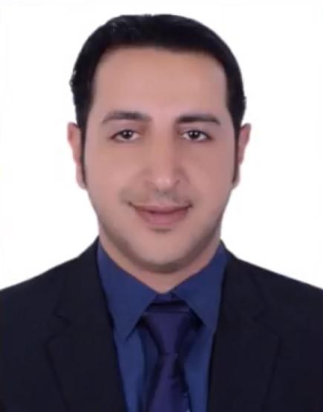
Hussain

Email: hussain.388183@2freemail.com

CAREER OBJECTIVE

15 years of specialized works in Implementation and development of the organization operations, classification and control of jobs, management engineering operations in the organizations of the Civil Service Bureau through the process of re-engineering, initiate the process of surveys of organizations and jobs in order to raise their efficiency, organization of the process of creation and modifying organizational structures, simplification of administrative procedures, creation , classification and reclassification of jobs, study tasks, job descriptions and ceilings of jobs by a qualified and specialized employees to conduct specialized studies, provide consulting services to achieve organizations with the efficiency and effectiveness.

Government entities in the Kingdom of Bahrain are governed by the policies and procedures set by the CSB, ensuring that all entities follow the overall civil service policy.

EDUCATIONAL QUALIFICATION

2006 -2010 Bachelor of Business Administration

1998 -2001 High School – scientific

CURRENT JOB

Mar 2005-Until Jan 2019 Civil Service Bureau (Bahrain)
(Organization, Engineering Management Directorate)
Team Leader

KEY RESPONSIBILITIES AS TEAM LEADER:

Supports team manager and performs management duties when manager is absent or out of office

Manages inventories and stock, including keeping detailed records of inventory use and sales, and advising management on ordering where necessary

Provides encouragement to team members, including communicating team goals and identifying areas for new training or skill checks

Assists management with hiring processes and new team member training

Answers team member questions, helps with team member problems, and oversees team member work for quality and guideline compliance

Communicates deadlines and sales goals to team members

Develops strategies to promote team member adherence to company regulations and performance goals

Conducts team meetings to update members on best practices and continuing expectations

1

Generates and shares comprehensive and detailed reports about team performance, mission-related objectives, and deadlines

Ensures company brand materials and physical working spaces meet and exceed company presentation standards

Provides quality customer service, including interacting with customers, answering customer enquiries, and effectively handling customer complaints

TEAM LEADERSHIP:

Conduct OJT (on job training) to make the team familiar with all systems, Monitor team performance, provide feedback for improvement, ensure team adheres to best work practices, and resolve staff conflicts.

CERTIFICATES AND COURSES:

2005 | (Aug) | Civil Service Bureau
 |  | Civil Service Policies and Procedures
2007 | (Apr) | Ministry of Interior (Civil Defense School)
 |  | Fire Emergency Evacuation Plan and the Fire Procedure
2007 | (Out) to 2008 (May)
 |  | Civil Service Bureau
 |  | Organizational and manpower skills - management and Behavioral skills
2008 | (Jun) | Capital Institute
 |  | Strategy of Electronic Recovery and Access to Data & documents protection
2008 | (Dec) | Civil Service Bureau
 |  | Manage time by Prioritizing
2008 | (Dec) | Civil Service Bureau
 |  | Work with organizational structures and job descriptions
 |  | (Part 1)
 |  | (Part 2)
2012 | (Oct) | Bahrain Institute of Public Administration
 |  | How to Improve Memory and Boost Brain Power

SPECIAL PROJECT IN CIVIL SERVICE BUREAU:
(FOLLOW-UP WORK PROGRESS)

Created a program which is designed to ease the workflow and make the work processes more efficient and more accurate in terms of studying and solving the problems. (It has received a reward

2

2005-2018 | Civil Service Bureau
 | Special Certification:

certificate of appreciation 2006 certificate of appreciation 2008 certificate of appreciation 2009 certificate of appreciation 2011 certificate of appreciation 2014 certificate of appreciation 2016

AWARDS

2006 special work Reward (Improve the Process of Government &Reduce expenses) 2009 Reward special work (promote efficiency & Improve Productivity of Services
in civil service)

2011 Suggestions Reward (System Enter data and extract work information)

2014 special work Reward (Improve the Process of Government &Reduce expenses) 2016 Encouragement allowance (Performance Level “Exceptional - consistently and
substantially)

SKILLS

- Operations Management 】【Facilities Management 】【Maintenance Planning 】
【 Resource Allocation 】【 Project Governance 】【 Project Quality 】
【 Safety Guidelines 】【 Resource Allocation 】【Workshop Management】

- Inventory Control 】【Performance Metrics Creation】

【Training & Development 】【Conflict Resolution】【Multiple Equipment Operations】【Performance Management】

COMPETENCIES

Excellent member in a teamwork starting enthusiastic and sociable. Familiar with using all Microsoft office packages..
Handling research programs.

System analysis and statistics development. Systems and procedures development.

Interpersonal and communication skills. Problem Solver.
Self Motivated. Flexible.

Creative. Accurate.
Strong organizational skills

3

INTEREST

Reading of different topics, surfing the web, and traveling.

PERSONAL INFORMATION

Marital Status: Married

Driving License: Bahrain, GCC

Language: Fluent in English and Arabic

4

