SAI KIRAN
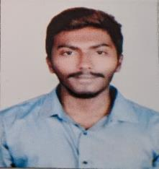

Email: saikiran.388185@2freemail.com

CAREER OBJECTIVE

Aiming to secure an opportunity to work with a reputed organization along with experienced employees where I can develop and utilise my skills efficiently and constructively for mutual growth of the organization and my career.

EDUCATIONAL QUALIFICATION

 | Name of the Institute | Board/University | Year of | Percentage/
Course
 |  |  | passing | CGPA
MBA (CPM) | Amity University, Dubai | Amity University |  | In
 |  |  | 2020 | Progress
B. Tech (Civil) | GITAM Institute of | GITAM University | 2018 | 5.8
 | Technology, Visakhapatnam
Intermediate | Sri Chaiytanya Junior College, |  | 2014 | 71%
 | Visakhapatnam | APBIE
10th | Kotak Salesian School, |  | 2012 | 66%
 | Visakhapatnam | ICSE
AREAS OF INTEREST

- Project management

- Green Buildings

- Construction management
Quality survey

- Qualitative survey

INTERNSHIP
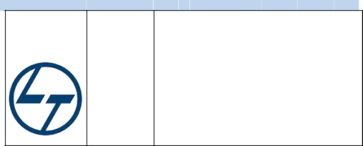
 |  | Description:
 |  | The Hyderabad Metro Project brings together best in class
LARSEN & TOUBRO | PROJECT :resources and technology in every aspect |  |  | of the | project-
CONSTRUCTION | METRO RAIL | Stations, Station planning, Track work etc. Metros and MRTS
 |  | (Mass Rapid Transport System) are emerging as a major area
 | CONSTRUCTION, for infrastructure development |  | in major | cities with | high
 | HYDERABAD | population. Integrated urban | transport | planning | using
 |  | intermodal connectivity and convenient sky-walks, which will
 |  | mark the beginning of an era of seamless commuting in India.
 |  | The report captures best practices and areas of excellence of
 |  | the project and also high lights areas of improvements and
 |  | recommendations to enable further excellence in delivery and
implementation of the metro rail project.

PROJECT

“WIND AND SEISMIC ANALYSIS ON TALL BUILDINGS” while distinguishing between IS875 part 3-1987 and IS875 part 3 -2015 codes for RCC high rise buildings under wind loads.

Project Description: A 15 storey Building, Different shapes of Tall Buildings, Schematic Representation of seismic Force, Variation of wind with increase in height.

- To calculate the body wind forces/intensities w.r.t sectional properties of the building.

- To study the gust factor method for both old and new code and draw comparisons between forces.

- To study and IS 875(part3):2015 code provisions.

- To study the wind pressure coefficient with respect to the shape of the structure.

- To study the k4(cyclonic factor) for the new code IS 875(part3):2015.

TECHNICAL SKILLS

- Designing Softwares: AutoCAD, STAAD Pro, Revit Architecture
- Management Softwares: Primavera P6
- Other Softwares: Microsoft Office Word, Microsoft Office Excel, Microsoft Office PowerPoint

WORK EXPERIENCE

- Worked as a Customer representative in Concentrix Daksh Services India Pvt . Ltd
  - Experience in Uber process , solving issues related to Uber riders

  - Understanding the role of customer representative in business field.

ACHIEVEMENTS & ACTIVITIES

Roles and Responsibilities:

- Event organizer of NIRMAAN – 2016 (Departmental fest).

- Organized guest lectures on Green Buildings, Smart cities, and Motivation in young minds.

Extra-Curricular:

- Member of University association that helps government school kids in academics
- Participated in many Fitness competitions

- Actively participated in activities like Swachh Bharat

PERSONAL COMPETENCIES

- Energetic and Socialized person.
- Effective communication & interpersonal skills.
- Confident and Determined.
- Self Motivator.

