RESUME
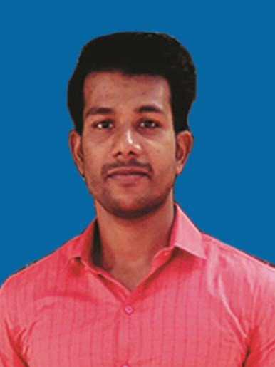

JUDE
Email: jude.388190@2freemail.com

Objective

To be a part of an organisation where gets a chance to use my knowledge and skills to contribute in the progress of the organisation as well as myself.

Educational

 | Year |  |  | Degree/Certificate |  |  | Institute/School, City |  |  | Percentage/CGPA
 | 2016 |  |  | M.Sc Physics |  |  | St. Xavier’s College, Thumba |  |  | 81%
 | 2014 |  |  | B. Sc Physics |  |  | St. Xavier’s College, Thumba |  |  | 78%
 | 2010 |  |  | HSS |  |  | St. Joseph HSS, Palayam |  |  | 84%
 | 2008 |  |  | SSLC |  |  | St. Joseph HSS, Palayam |  |  | 85%

- Since 2016 preparing for the competitive examinations (Public Service Commission and UPSC).

- Since 2012 working as a tutor in different tuition centres as Physics teacher for the students of high school to higher secondary.

Skills
THEORETICAL SKILLS
• Artificial Intelligence. |  |  | PROGRAMMING LANGUAGES
 |  |  | • C : Novice.
• Numerical Methods.
 |  |  | • C++ : Novice.
• Digital Signal Processing.
 |  |  | • Python: Novice.
• Advanced Electronics Communication.

Applications suites

- MS Word: Well known.

- Excel: Well known.

- Power point: Well known.

Academic Project

- Experiment Analysis Of Numerical Aperture and Misalignment Loss Of Multimode Optical Fibre.
- Effect Of Tension On Membranes Of Negative Bulk Modulus Acoustic Metamaterial Based Filters.

Page 1 of 2

RRRES

Seminars Attended

- National Seminar on Scope and Challenges.

On Tensor Analysis by Dr. Sethumadhavan and on XRD by Dr. Namboothiri.

Positions of Responsibility

- Serving as a tutor (Physics teacher) in high school (8 to 10) since 2012.
- Active member of blood donation program conducted by the college in the year 2014.

- Co-ordinator and presenter of seminars in the class of M.Sc at the time of studying Masters Degree in the duration of 2014-16.

Contacts and PersonaI Information

- DOB: 24 December 1991.

- Address: JUDY HOUSE, TC 44/397, VALIYATHURA, VALLAKADAVU P.O. TVM 695008, Kerala, India.

- Secondary Contacts: +91 9400504589(Father/Guardian), 04712507589(Residence).

Page 2 of 2

