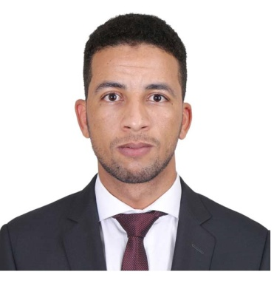
Name : EL MOULI

Email: elmouli.388196@2freemail.com

Training and Work experience:

Designation: IP Paralegal, February 2016 -Present

Job Profile:
- Advising on the protection, registration including prosecution of trademarks, patents, copyrights and designs for GCC countries.
- Management of client’s portfolios including protection and enforcement with overall responsibilities of client cases from instruction to completion.
- Providing legal advice and counsel on assignments and licensing and other intellectual property.
- Conducting full availability searches and providing a legal opinion on the registrability of trademarks.
- Conducting watch services for published trademarks.
- Preparing publication, registration and all forms related to trademarks.
- Issuing notices in stages like filing, acceptance/ rejection, publication, opposition and registration.
- Translation of legal documents from English to Arabic and vice versa.
- Company representative at The UAE trademarks and patents departments.
- Knowledge of trademarks, designs and patents UAE online prosecution.
- Submission of Trademarks applications and management of Trademarks portfolio.
- Preparing trademarks, patents & designs applications and filing them using the UAE trademarks & patents online system and following up their progress till final registration and issuance of the relative certificates.
- Maintenance of intellectual property titles by effecting renewals and annuities.
- Working on both non-contentious and contentious matters, including attending hearings and handling oppositions on behalf of clients.

Company and location : JAH & CO. IP (Head Office)Doha – Qatar
Designation : Trademarks Consultant, February 2015 - January 2016

Job Profile :
- Providing pre-filing advice to a range of clients.
- Providing trade mark clearance searches and advising clients accordingly.
- Filing and prosecution of trade mark applications.
- Registration of trademarks, patents and designs.
- Advising clients in relation to other IP matters.
- Assisting with the further development of the trademarks practice.
- Providing legal advice and counsel on assignments and licensing and other intellectual property.
- Conducting full availability searches and providing a legal opinion on the registrability of trademarks.
- Maintenance of intellectual property titles by effecting renewals and annuities.
- Conducting watch services for published trademarks and patent.
- Preparing of trademarks, patents and designs applications.
- Preparing publication, registration and all forms related to trademarks.
- Issuing notices in stages like filing, acceptance/ rejection, publication, opposition and registration.
- Translation of legal documents from English to Arabic and vice versa.

Company and location: The Moroccan High Planning Commission
Designation : Statistical officer ,15th August 2014- 20th September 2014

Academic Qualifications:
- Faculty of Arts and Humanities of Ain Chock Casablanca: BA degree in English Literature 07-2014.
- Faculty of Arts and Humanities of Ain Chock Casablanca: Associate’s degree in English Studies 07-2013.
- Ibn Sina High School: Baccalaureate Literary 06-2011
Conferences:
INTA – Company conference delegate: May, 2018 (Seattle-USA)
INTA Middle East and Africa –Company Conference delegate: December, 2018 (Dubai- UAE)
Additional Skills:
- Instrumental in arranging for country visit and meeting existing clients and also assist in sourcing potential clients for the firm various offices.
- Willing to work hard in a team environment.
- Ability to listen to the concerns of others.
- Constantly measuring own performance against set expectations.
- Have a pro-active work ethic.
- High degree of integrity and professionalism.
- Able to work on own initiative and unsupervised.
- Experience with Microsoft office Suite e.g Word, Excel, Power Point and Outlook.
- Holding a UAE driving license.

Languages:
- Classical Arabic: Perfect
- English: Fluent
- French: Communication
- Tamazight: Fluent

