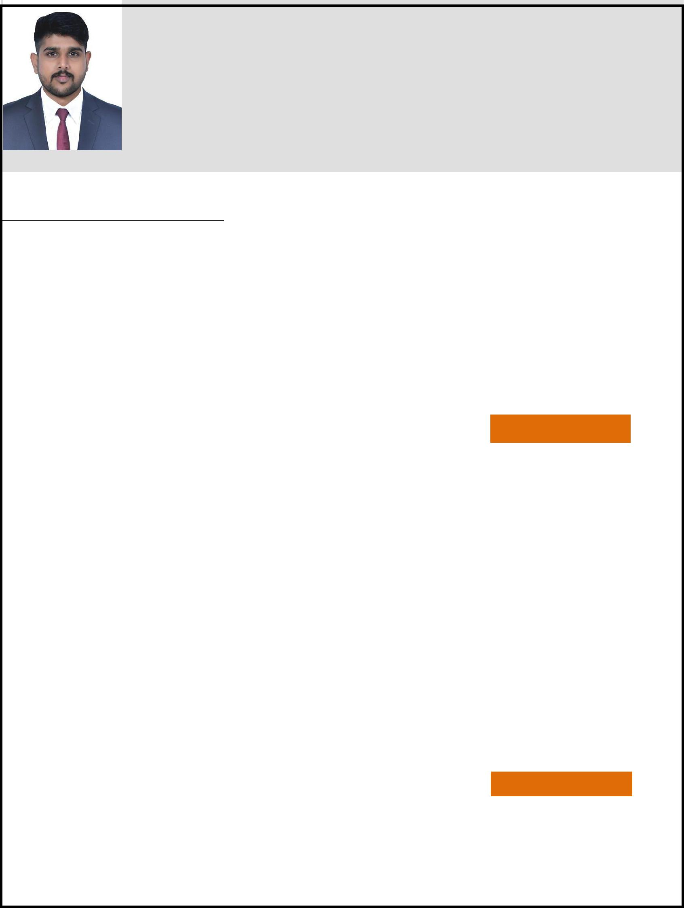
SARATH
Email: sarath.388207@2freemail.com

Career Objective

To obtain a challenging position in a high-quality engineering environment where my resourceful experience and academic skills will add value to organizational operations. Always willing to work as key player in a challenging and creative environment.

Career Profile

- Having 2 Years of work experience in Civil Engineering & Interior Designing. Excellent execution experience, including setting goals and objectives, project development, planning and Organization 
Professional Experience

Civil draughtsman -

Reem capital contracting LLC. Dubai

JUNE 2017 – DEC 2018

Projects:
- EATON PLACE (G+P+4) RESIDENTIAL BUILDING ON AT JVC, DUBAI 
- BELGRAVIA 3 (G+1P+4F+ROOF) RESIDENTIAL BUILDING AT JVC, DUBAI 
Key Responsibilities:
- Created shop drawings for approval from consultant

- Drafted detail drawings for the engineers to do work on the site.

- Reviewing information for completeness and accuracy.

- Makes necessary calculations for drawing development.

- Prepares As-built drawings in the prescribed computer sheet given by the Client/Consultant and assist in

- Project Close-Outs.

- Maintains knowledge of Company standards and incorporate these into engineering design.

- Performs other duties and responsibilities as may be assigned from time to time.

- Create coordinates for the surveyors.

- Observed and evaluated structural conditions.

- Employed team-orientated problem solving.

Site supervisor - Residential Projects
Boss builders & Developers - Kerala, India _{JUNE 2015 – JUNE 2016}
Key Responsibilities:
- Interpretation of drawings and guiding the contractors to execute the work.

- Checking fit ups, arranging the resource.

- Resolution of site problems and requests.

- Ensure that the work is carried out as per standards, drawings, maintaining quality

- Supervise the work and give necessary clarifications to the workers.

Educational Qualification

Diploma in Civil Engineering
Hindustan Polytechnic College - Coimbatore
Department of Technical Education - Tamil Nadu, India. (2013-2015)

Quantity Surveying & Contract Administration
Vibgyor institute of quantity surveying & contract management ,As per RICS-Thrissur(2015)

ITI Draughtsman (civil)
Global Private Industrial Training Institute ,Alagappanagar , Thrissur(2010-2012)

AUTOCAD,Revit Architecture,3DS Max
CADD centre training institute Irinjalakuda, Thrissur

Technical Skills

- Experienced in the usage of Microsoft Windows based Operating Systems.

- Experienced in the usage of AutoCAD, Revit Architecture, and 3Ds max

Personal Details
Nationality | : Indian
Gender | : Male
Marital status | : Single
Languages Known | : English, Malayalam, Hindi, Tamil

