CURRICULUM VITAE
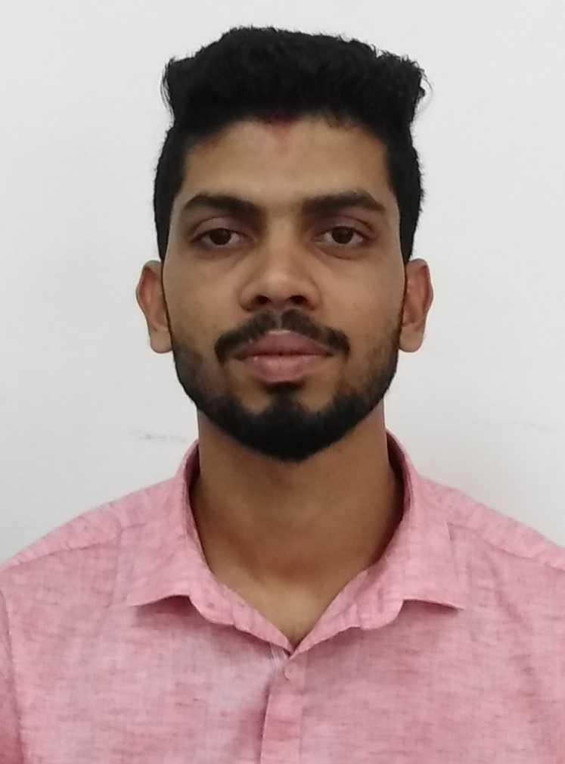

PRAKASH
Email: prakash.388226@2freemail.com

To obtain a meaningful and challenging position that enables me to learn the new skills and gives me environment to contribute in the organizations growth as well as self-development.

WORK EXPERIENCE

- Currently working as Accountant in Al Mardas Printing Press, Muscat, Oman (from November 2018 to till date)
- Worked as Accountant in Royal world Facilitators Private Limited, Paduvinangady Junction, Mangalore (From November 2017 to November 2018)
- Worked as Accountant in Sri Balaji Hardwares, Bunder, Mangalore(From April 2017 to October 2017)
- Worked as Accountant in Gulf Converting Industry LLC, Muscat, Oman. (From January 2014 to January 2017)
- Worked as Junior Accounts Assistant in Karnataka Fisheries Development Corporation, Hoige Bazaar, Mangalore (From July 2013 to January 2014)
- Worked as Audit Assistant under C.A N. Keshava Ballakuraya, Ballalbag, Mangalore (From May 2012 to June 2013)

JOB RESPONSIBLITIES

- Maintaining of Book of Accounts Manual / Computerizes as per Tally or Company internal accounting package.
- Preparing and posting of Petty cash or Cheque Vouchers.
- Preparing Trial Balance, preparing Monthly and yearly P&L account.
- Monitoring Accounts Receivables, Payables and Income and Expenses statement.
- Maintaining track of Customers / Buyers balance with ageing and followed by collection process to remind if any overdue still pending.
- Preparation of Invoice and Delivery Order.
- Handling Sales and Purchase Register.
- BRS preparation for weekly basis.
- Preparation of Ageing Debtors and Creditors for the given period.
- Maintaining of Inventory control system for Production process and report generation for Monthly consumptions and stocks to update.
- Maintaining Employees Documents, Attendance sheet preparation etc.,
- Preparation of LPO.
- Assisting in Auditing.
- Assisting in Administrative works.
- Maintaining MIS Report.
- Preparation of Payroll (WPS) and Time Sheet for Employees.

EDUCATIONAL CREDENTIALS

Exam Passed | Name of the College | Name of the University | Year of Passing | % of Marks
B.Com. (Degree)  P.U.C.  S.S.L.C. | Canara First Grade College, Mangalore.  Canara Pre-University College, Mangalore.  Infant Jesus Joyland School, Mangalore. | Mangalore University.  Pre-University  Education Board, Karnataka.  Karnataka Secondary Education Examination Board. | 2012  2009  2007 | 57.54%  58%  72.32 %

ADDITIONAL QUALIFICATION

- E-office (Windows, MS Word, MS Excel, Internet) and
Tally. (Version ERP 9)

INTERESTS
- Listening to Songs.
- Traveling.

LANGUAGES KNOWN

- English, Hindi, Kannada & Tulu.

PERSONAL PROFILE

Sex : Male

Marital Status : Unmarried

Religion : Hindu

Nationality : Indian

