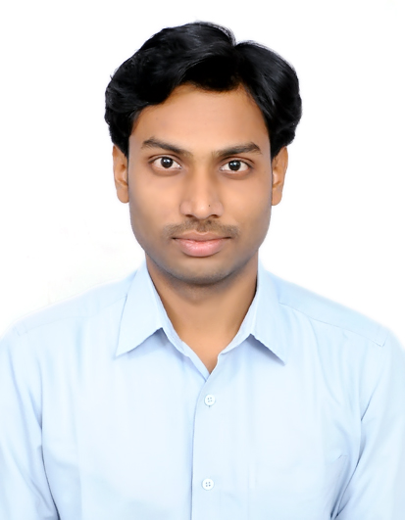Harivignesh

Email: harivignesh.388229@2freemail.com

OBJECTIVE: To have a growth oriented and challenging career, where I can contribute my knowledge and skills to the organization and enhance my experience through continuous learning and teamwork.

QUALIFICATION:
- Bachelor’s Degree in Mechanical Engineering (2015) - Adhiyamaan College of Engineering, India with CGPA: 9.01.

ACHIEVEMENTS:
- Undergone 14 energy audits in textile industry and saved considerable amount of energy in compressed air system.
- Eliminating machine failures which resulted by decrease in downtime by 13%.

SOFTWARE KNOWN:
- AUTO CAD 2010
- CATIA V5 R20
- Microsoft Office

EXPERIENCE:
SITRA, Coimbatore, India - Energy Audit Engineer Apr 2017 - Jan 2019
- Analyze equipment performance with respect to energy efficiency.
- Compare existing energy consumption levels to normative data and calculate potential energy savings.
- Establish data recording, collection and analysis system to keep track of energy consumption.
- Identify and prioritize energy-saving measures.
- Prepare audit reports containing energy analysis results and recommendations for energy cost savings.
- Quantify energy consumption to set up baselines for energy use.

Prumatech Services Pvt. Ltd., Chennai, India - Graduate Engineer Trainee Oct 2015 - Sep 2016
On-Site Project: ITC LTD, SBU – Packaging and Printing, Chennai, India
- Analysis of machine failures.
- Assessing the needs of equipment replacements & spare parts.
- Daily performance of machines, calculation and reporting at monthly basis.
- Diagnose causes of malfunctions by sight, sound, or actions of machine.
- Repaired and maintained pumps, blowers and pneumatic systems.
- Performed preventive maintenance as well as condition based maintenance.
- Replacing the spare parts of the machines as and when.
- Responsible for maintaining an inventory for the requirement of the supplies and spare parts.
- Responsible for performing routine maintenance.

PERSONAL DETAILS:
- Nationality : Indian
- Gender : Male
- Marital status : Single
- Languages known : English & Tamil

