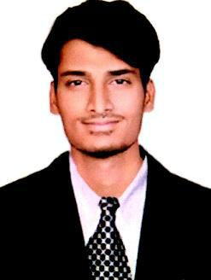

THAYEEB
Thayeeb.388299@2freemail.com

CIVIL DRAFTSMAN

CAREER OBJECTIVE

To seek a challenging position with an organization that provides an atmosphere that leads to growth of my career,while utilizing my skills and capabilities with over 2.5 years of experience in Designing and Drafting in BIM.

KEY SKILLS AND COMPETENCIES
 | REVIT |  | AUTOCAD |  | SKETCHUP
 | BUILDING INFORMATION |  | ADOBE PHOTOSHOP |  | MICROSOFT WORD
 | MODELLING
 | MICROSOFT EXCEL |  | MICROSOFT POWERPOINT |  | WINDOWS OPERATING SYSTEM
- DRAFTSMAN

PROFESSIONAL ABILITIES

- BIM Modelling for specific design discipline.
- Designing and managing the buildings.
- Collaborating and coordinating with other discipline changes.

- Drawing and Printing the Cad and Bim files.
- Preparing own discipline Models.
- Ability to export and import drawing files with internally and externally.
- Preparing the detail drawings for residential and commercial buildings.
- Creating and storing data.
- Meeting with clients and coordinators.

- Designing and drafting of architectural specifications.
- Clarifying the issues raised and concerning about technical issues .
- Handling the project and submission of work.
- Completion of project before the deadlines.

PERSONAL ABILITIES

- High Patience.

- Respect for Dignity.
- Team Player.
- Adaptibility.
- Decision making.
- Problem solving.
- Flexiblity.

- Time Management.

CAREER HISTORY

Associate BIM
Avineon India Private Limited -India

Junior Architectural Draftsman

Imarat consulting services-India

Designing Intern

Cantercadd-india

ACADEMIC QUALIFICATIONS

HIGH SCHOOL Schooling

BOARD OF INTERMEDIATE | Intermediate
JAWAHARLAL NEHRU TECHNOLOGICAL | Civil engineering
UNIVERSITY

AVAILABILITY | : | IMMEDIATElY.

MARCH 2018-DECEMBER 2018

MAY 2017 - MARCH 2018

DECEMBER 2016 – MAY 2017

2006 - 2011

2011 – 2013

2013 - 2017

