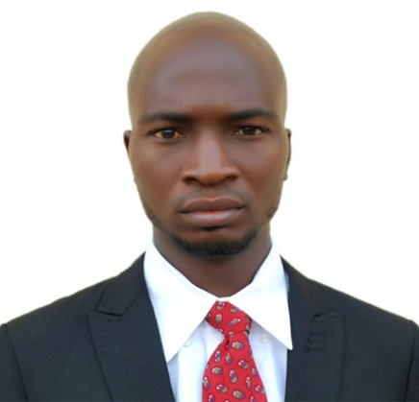
ADERINBOYE
E-mail: aderinboye.388313@2freemail.com

OBJECTIVE
To become the best in what I do and contribute my knowledge towards making the organization I work with, a leading one in the economy and to deliver excellence to any organization culture involved in. at the same time improving my human resource, management administrative and communication skills.

SKILS AND COMPETENCES

- Strong relationship building skills
- Good interpersonal skills and works well in a multicultural environment
- Excellent communication skills
- Ability to meet tight reporting schedule
- Creative innovation and adapt easily to new situation
- Excellent ICT skills
- Good in Microsoft office suite
- Results oriented
EDUCATIONAL BACKGROUND:
2013 University of Nigeria, Nsukka Enugu State
Bachelor of Science in Education (Economics)

2009 Local Government Secondary School, OhianaOkene. Kogi State
Secondary School Certificate Examination

2002 Adeolu Nursery & Primary School, Owo Ondo State
First School Leaving Certificate

PROFESSIONAL QUALIFICATION

- Emirate fire and rescue company training 2017
- Project management 2016
- Entrepreneurship development 2015

PROFESSIONAL EXPERIENCE
Adenuga & son Company Limited, Daura katsina state sep 2013 – jun 2016
Administrative Assistance
- Prepare presentation, reports, and documents
- Reporting skills and administrative writing skills
- Ability to manage processes and analyze information
- Excellence organizational skills with high attention to detail
- Problem solving skills
- Excellent communication and interpersonal skills needed along with a ‘Can Do’ attitude
- Ability to multi-task and change direction quickly
- Be a team-player and be able to work on initiative in a dynamic and challenging environment
- Ability to demonstrate initiative and honed organization skills
- Manage calendars
- Scheduling appointments and managing social medial and general staff support
- Manage small project and help define new operational strategies
- Conducting research

LANGUAGE SPOKEN
- English and learning Arabic

HOBBIES
Reading, Sport, Travelling and Meeting people

