Curriculum Vitae
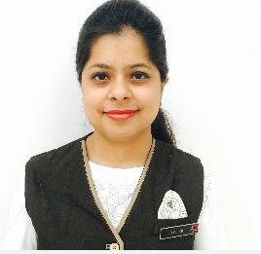Ruchika
Email: ruchika.388352@2freemail.com
Career Objective
To work with an organization providing maximum exposure and nourishment to my skills, innovating and performing by influencing and empowering a situation or an idea. A competent professional with hardworking attitude and adaptability towards any working environment.
Key Attributes
- Ensuring customer satisfaction by delivering the highest service quality.
- Highly dynamic individual with superb guest handling attitude and positivism.
- Excellent team member with all the key attributes required to run the operations efficiently.

Work Experience

- Vivanta by Taj Lucknow, as Front office Supervisor from 2015 -2019.
- Vivanta by Taj Pune, as Front Office Assistant from 2014-2015

Educational Qualifications

- B.Sc. in Hotel Management from IHM Bhopal (2011-2014)
- Higher Secondary from Dr. Virendra Swarup Education Centre Avadhpuri, Kanpur (2009-2010)
- Senior Secondary from Dr. Virendra Swarup Education Centre Avadhpuri, Kanpur (2008-2009)

Current Roles and Responsibilities
- Have detailed information regarding arrivals and room requirements.
- Maintaining the files, records and documents as required.
- Handling Telephonic and Walk-in enquiries.
- To co-ordinate with housekeeping to ensure rooms are ready as per standard time for all arrivals.
- Taking care of FIT and group arrivals.
- To ensure ready room is allotted to early morning arrival as per preferences.
- Ensuring all VIPs & Single Lady travellers are escorted to rooms.
- Maintaining the Log Book and effective follow up follow up points.
- Handling shifts and in absence of Duty Manager.
- Ensuring norms, procedures and systems for safety and security of guest belongings (e.g. Lockers, Left luggage etc) are followed.
- Ensuring that all the statutory requirements for in house guests are met (C–Forms etc).
 
Achievements
- Qualified Star Levels at Taj Group Of Hotels, Lucknow
- Silver Level, Gold Level, Platinum Level, Senior VP Level

Computer Proficiency
- Excelled in browsing Internet
- Proficient in using OPERA software
- Proficient in MS Office

