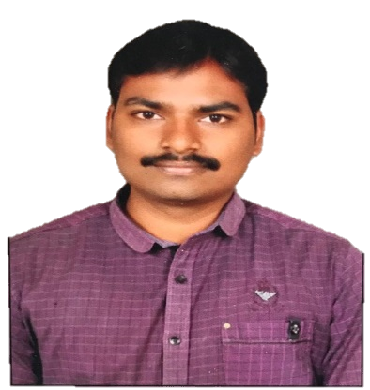
CURRICULUM VITAE
BALASRIDHAR

Email: balasridhar.388406@2freemail.com

Objective:
To work in environment where there is scope to improve knowledge and skills to my potential adding value to the organization.
Education:
Completed B.Tech in Electrical and Electronics Engineering at JNTUH

Professional Summary:
- Having 4+ years of experience in Exide Industries Ltd.
- Having 3+years of experience in VASAVI POWER SERVICES Pvt. Ltd.

Professional Experience:
- Worked as a Technical Commission Engineer for Exide Industries Ltd., Hyderabad from June 2011 to July 2015
- Working as an Electrical Engineer for VASAVI POWER SERVICES Pvt. Ltd. From July 2015 toDEC2018.

Project Profile:
Compagine du electric Senegal, Senegal West Africa
Current Employer : VasaviPower Services Pvt.Ltd.
Client : PromacEngineering Industries Limited.
Designation : Project Execution Engineer.
Duration : July, 2017 to Dec, 2018.
Job Responsibilities:
As an Electrical Engineer I have overall responsibility for all execution & estimating jobs, under my control, reporting directly to the project manager.
- Execution of technical jobs and troubleshooting of UPS system(220v)
- Erection and commissioning of UPS systems like 5KVA,10KVA,127KVA Battery units with chargers
- Monitoring the critical activities based on the project schedule
- Participate in project meetings and discussions with the client
- Providing technical support to the executive supervisors
- Installation, testing and commissioning of COLTS(condenser online tube cleaning system)
- Installation and erection of (Transformers , DG, LV Panels, HT Panels)
- Familiar with Cable tray erection, Cable laying & Terminations, Panel Erection, Earthing Works.
- Erection of Electrical Panels, lightings as per drawings & executed firefighting systems as per safety drawing approvals.
- Guiding workers to execute allocated work to them and ensuring timely completion of site work in allocated time line.

Personal Particulars:
Nationality : Indian
Marital Status : Single
Permanent Residence of : India
Date of Birth : 03-08-1990
Gender : Male
Languages : English, Telugu, Hindi

