CURRICULUM VITAE
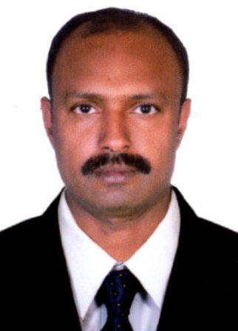

SHIJO

Email : shijo.388830@2freemail.com

CAREER OBJECTIVE

Seeking for a Challenging and creative Administrative, Finance/Accounting Position

SKILLS

Accounts Receivable, Payroll, Banking Operation, Petty cash , Main cash, Reconcilation Oracle and SAP 15 Years Working as an Accountant, 10 Years in India 3 Years in KSA And 2 Years in Qatar

PROFESSIONAL EXPERIENCE

- JUNE – 2002 – MARCH 2004 Accountant:- Myladoor Rubbers, Thattarathatta Thodupuzha, Successfully handing in cash, Banking & Payroll

- APRIL- 2004 – MARCH 2006 Financial Manager :- Asian Trading Company, IMA Road, Thodupuzha, Charged for cash, Banking & Interstate Trade

- APRIL 2006 – MARCH 2011 General Manager:- Myladoor Rubbers, Thattarathatta Thodupuzha, Promotion with General Manager, Charging iver all Business.

Supervise 300 employees & 5 junior Managers.

- NOVEMBER 2011 – JULY 2014 Payroll Accountant:- Nasser S Al Hajri Corparation,Industrial Contractors,KSA Yanbu Region,Successfully Handing Paryroll for 3000 Emloyees- Monthly salary, incentives & Vacation Settlement

- JANUARY 2016 – MARCH 2018 Accountant Receivable – Salco Trading & Contracting Est. Qatar Accounts Receivable , Main Cash, Payroll, Vacation Settlement.

PROFESSIONAL SKILLS

- Strategically planning & implementing the systems , policies & procedures to Initiate and control finance and projected towards organizational goals to maximize profitability and generate revenue

- Admission of new employees in Payroll System and record, their basic – details confidentially – Basic Salary. Normal Working Hour & Bouns.

- Guidance to junior Accountants, preparing monthly salary for staff & workers, monitoring leave

records and daily attendance Organizing monthly salary transfer Instruction, monitoring its confidentially and taking approval from chief

•Employee advance Payments and its collection. Preparing the leave salary, gratuity and end of service benefits at the time of employees vacation.

- Kept the staff & workers Salary records, increments and bouns record confidentially

- Checking daily sales report of each sales Man.

- Assisting Sales Man to collecting the payments in agreed time period

- Properly kept customers account and reminder customer and sales man to collect cheque and cash shown in ageing report

- Customers account reconciliation in time to time and reporting to management

- Collect customers Balance Conformation at the end of each year and rectify the variance

- Create a healthy relationship between customers and salesman

- Depositing the collated PDC Cheque and cash in Bank.

- Help finance Manager to Annual Auditing and healthy relation in customers & Employees

PROFESSIONAL QUALIFICATION

2004-2006 Diploma in Management – Indira Gandhi National Open University

Enrollment Sale Tax Sales Tax Practitioner in KVAT, Enrl No. 314,A5-45-45/09 dated 13/01/2010.

ACADEMIC QUALIFICATION

2001-2002 M.com with First Class (Finance) M G University kottayam

1996-2001 B.com Second class (Costing & Co – Operation) M G University Kottayam

1994-1996 Pre – Degree, M G University Kottayam

PERSONAL DETAILS

 |  | Religion & Caste | : Christian R.C.S.C
Sex | : Male | Language Known | : English, Malayalam
Marital Status | : Married
Year of Birth | : 29-01-1979
Nationality | : INDIAN

