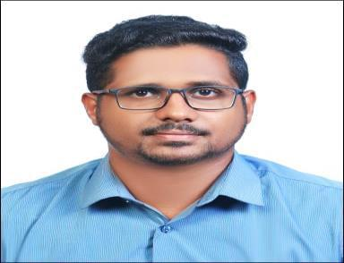

MATHEW

Email: Mathew-388868@2freemail.com

CURRICULAM VITAE

Career objective

To have a growth oriented and challenging career, where I can contribute my knowledge and skills to the organization and enhance my experience through continuous learning and teamwork.

Academic Qualification

Qualification | Board/ University | Year | Percentage
BE in Mechanical Engineering | Anna University, Chennai | 2012-2016 | 64.9%
Higher Secondary | State Board Of Kerala | 2011 | 74%
SSLC | State Board Of Kerala | 2009 | 70%

Work Experience

SITE ENGINEER( Piping and Structure )[09-06-2016 to 31-12-2018]
Job Description:

- (M I) Material Identification Check List Report to Client.

- Responsible for all documentation in QA/QC .

- Meet with clients to oversee installation, operation, and maintenance of equipment for all local plants.

- Conducting (TOOL BOX TALKS) with workers and discussing safety precautions before engaging in work.

- Handling manpower according to need for proper work output.

- Witness during heavy erection of structure and pipe lines

- Giving instruction to technicians to do work as per drawing.

- Responsible for proper assembly of structure parts as per drawing.

- Responsible for clearing work permits before starting the job and checking if the workers are provide by proper safety equipments.

- Preparation of daily progress report to estimate the duration and man power.

- Planning of jobs according to time management and benefit for company.

Industrial Shutdowns Experiences

- 45days capital shutdown in COREX PLANT in ESSAR STEEL INDIA LTD.

- 15days capital shutdown in HOT STRIP MILL in ESSAR STELL INDIA LTD.

- 10days capital shutdown in SINTER PLANT in ESSAR STEEL INDIA LTD.

- 7days shutdown in BLAST FUNUS in ESSAR STEEL INDIA LTD.

Software proficiency

- Software known: Basics Auto Cad, SolidWorks, Ansys, Revet
- Office suite: MS-office, Power point

Implant Training

- Titanium Dioxide Pigment Unit of The Kerala Minerals and Metals LTD, Chavara, Kerala

Industrial Projects
• | Project Area | : Fabrication and Erection of pipeline
 | Project Title | : “UTILITY PIPING PROJECT WORK”- 14 inch and above In
 |  | ESSAR STEEL INDIA LTD, Hazira, Surat
 | Project role | : Site engineer
• | Project Area | : Fabrication and Erection and Assembly
 | Project Title | : “TAIL GAS HOLDER PROJECT FOR HBI” In ESSAR STEEL INDIA
 |  | LTD, Hazira, Surat
 | Project role | : Site engineer

Technical qualification

- NDT Level 11

- Process Piping Design and Engineering as per ASME B31.3

- QC and QA

- Welding inspection

- HVAC

- Mechanical and Electrical Plumbing

Personal strength

- Ability to work and co-ordinate in a team effectively

- Hard working

- Excellent verbal and written communication

- Quick learner, Optimistic

- Positive attitude

- Ability to manage multiple task and deadlines

- Good communication skill

Area of Interest

- Manufacturing Technology

- Steel Industry

- Production

- Gas and oil refinery

- Automobile Engineering

- Thermal Engineering

