CURRICULUM VITAE

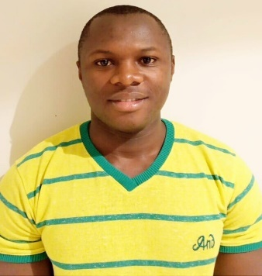
BIO DATA

Name : Hassan
Sex : Male
Email : Hassan-389770@2freemail.com
Visa status : Residence Employment Visa

POSTION APPLIED FOR:ENGINEER HELPER

CAREER OBJECTIVE:-
I am looking for a better environment to be associated with a progressive organization which can provide me with a dynamic work sphere to extract my inherent skills as a professional, use and develop my attitude to further the organization’s objectives.

EDUCATION BACKGROUND
AWARD  Food & Beverage Training  Kenya Certificate of Secondary Education | INSTITUTION  The Sands at Nomad Beach Hotel  Redeemed Academy High School | YEARS  2008  2006
WORKING EXPERIENCE

Date: 30th June 2017 till date
Company: National Catering Company W.L.L. – Abu Dhabi U.A.E
Position: Waiter
Duties:

- Welcome customers when they enter your restaurant & escort them to their table. If they have a reservation or specific table requests, be sure to accommodate them
- Give guests menus once they have been seated and be prepared to provide detailed information on ingredients, food allergies, how the food is cooked, recommendations, and the specials of the day.
- Prepare tables and clean when customers have left and replace silverware, table cloths, and glasses with clean ones.
- Take accurate food and drink orders with an easy-to-use POS system
- Always communicate with kitchen staff on orders or any issues.
- Check dishes and kitchenware for dents or breaks
- Serve food and drinks straight away so that they don't go cold (or warm)
- Remove plates and cutlery from the table
- Ask customers if they'd like desserts, tea, or coffee
- After serving timings normally we do cleaning duties such as sweeping and mopping the floors, vacuuming, tidying up the server station, taking out the trash, and/or cleaning the restrooms.

Date: 2015 - 2017
Company: Neptune Beach Hotel, Mombasa Kenya
Position: Waiter

Achievements
- Developed soft skills in all dealings.
- Developed a positive attitude towards health and safety around the work environment.
- Improved time management skills.
- Developed self confidence in relation to workers and environment.

Languages Spoken

Englishfluent in both written and spoken

Swahili fluent in both written and spoken

Personal Strengths
I am an objective, dynamic and determined individual with a desire to achieve, ability to work under pressure,minimum supervision, with a willingness to learn from others.

Hobbies
- Football
-Traveling, both by road and air.
-Networking with people of different walks of life.

Skills
-Computer literacy in all packages.
-Strong negotiation bargaining skills

