CURRICULUM VITAE
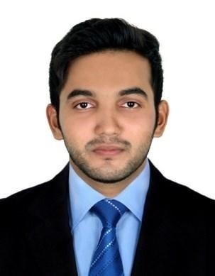
ASHIQUE
ACCOUNTANT

E-mail : Ashique-389814@2freemail.com

OBJECTIVE
Becoming an accountant isn’t something that you just fall into; it requires years of training and a strong set of skills

ACADEMIC BACKGROUND

EXAMINATION | BOARD/UNIVERSITY | COMPLETION YEAR
Bachelors of business
management(BBM) | Mangalore University | 2016
Diploma in Corporate Accounts
and  Management(DCAM) | Ass Institute | 2017

WORK EXPERIENCE -1 Year & 5 Month

Sovereign Industry LLC, Ajman, U.A.E. (From 2018 May 22 to September 26, 2018)).
: Accounts Assistant
- To manage accounts payable (bill payments, salaries, petty cash etc.) and receivable through cash/Cheque/voucher in a timely manner.
- Preparation of Financial Statements i.e. from General Entry to Ledgers, Trial Balance, Profit & Loss account and Balance Sheet.
- Perform Cashier duties including receipts and payments at the front desk.
- Buying & Selling of Co. products and preparing of related documents.
- Contributes to team effort by accomplishing related results as needed
- Preparation of books of accounts & bank reconciliations,
- Preparing and filing of VAT returns

Accountants Service Society, Kochi, Kerala, India. (From 2017 June 16 to March 21, 2018).
: Accountant
- Preparation of Financial Statements i.e. from General Entry to Ledgers, Trial Balance, Profit & Loss account and Balance Sheet.
- Registering all accounting entries using Accounting Software.
- Assisting institutions with the preparation of year-end returns (creditors, debtors, payments ,and receipts in advance)
- Contributes to team effort by accomplishing related results as needed
- Preparation of books of accounts, bank reconciliations, vouching, ledger scrutiny and preparing financials up to finalization.
- Recording Day-to-day Transactions

COMPUTER PROFICIENCY

- Accounting Software : TALLY ERP 9, SAGE, QUICKBOOK, SAP FICO, SAP BUSINESS ONE
- MS OFFICE (WORD, EXCEL)
- Email Application and Internet Research

HOBBIES

- Earing Music
- Traveling
- Playing cricket, football
- Driving

PERSONAL DETAILS

- Date of Birth |  | : 18-05-1993
- Language Known |  | : English, Hindi, Malayalam, Arabic (Read &write)
- Marital Status |  | : Single
- Nationality |  | : Indian
- Visa Status |  | : Visit Visa(valid till June 25,2019)

