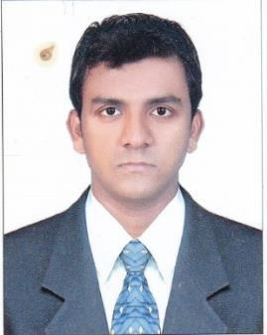

Joseph K.D

Email joseph-389832@2freemail.com

Seeking assignments in Technical Services and/ or Administrative Assistant with a high reputable organization. A key personnel aimimg to help achieve Company goals and willing to take challenge for different responsibility as my require

Profile Snapshot

- Bachelor of Hotel Restaurant Management ( BS HRM) With 8 year experience in McDonalds Fast food Comp.UAE ( Swing Manager)

05 February 2011 to 08 January 2019

  - Done 6 months INDUSTRIAL EXPOSURE TRAINING in F&B Service Department In D.V.Manor, Vijayawada, Andhra Pradesh, India (16.06.2007 to 02.12.2007)

  - .Worked as a TEAM SUPERVISOR (3 Years) in ABAD FOOD COURT, Cochin, Kerala

Has Passed the TSI Quality Services Person –In-Charge Level 3 Award

Work Experiences and Responsibilities:

February 2011 to January 2019 – McDonalds UAE (Dubai Area)

Swing Manager
- Providing Outstanding Service Quality.

- Cross-selling and providing the information about the products especially the promotional items that we are serving to the customers.

- Meeting the targets at all times during operational hours (i.e. Delivery Service, Drive Thru, Counter Area and Kitchen Area).

- Responsible for completing all the necessary documents that we need for Training purposes including the audits provided by the company (i.e. HR and Quality Audits).

- Providing training for the new staff and giving feedback (verbal and written) regarding their performance within the training period.

Service Staff
- Providing Outstanding Service Quality.

Cross-selling and providing the information about the products especially the promotional items that we are serving to the customers.

- Meeting the targets at all times during operational hours (i.e. Delivery Service, Drive Thru, Counter Area and Kitchen Area).

Technical Proficiency

Software : MS Office, Internet

Strengths:

- Highly motivated, innovative and having Good communication skill & hard working& up to date

- Sound knowledge in computer skills &Adaptable to new environments, changes and attitude to continuously upgrade understanding on the evolving concepts.

- Attitude to work in teams and lead them for success

Language Known:

Malayalam, English, , Tamil, Hindi.

Personal details:

Name | : Joseph K D
Date of Birth | : 26/07/1987
Sex | : Male
Nationality | : INDIAN
Marital Status | : Single
Religion | :Christian

I hereby declare that the information furnished above is true to the best of my knowledge.

Thanks& Regards

Joseph

