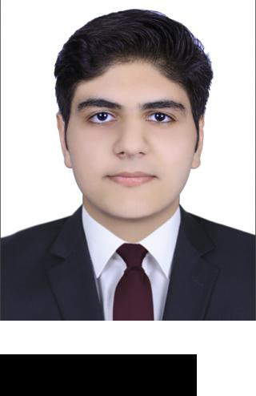

OBJECTIVE

PERSONAL INFORMATION

EDUCATION

SKILLS

REFERENCES

Dharmik
Email: dharmik.389882@2freemail.com

Looking for a challenging career, where there is a scope for demonstration, always on a look out for a positive and bigger outlook. I am willing to give my total support to the organization that I am in, with the experience and capability that I have, in order to achieve the organization’s goals and objectives and create mutual benefit.

Date Of Birth | - | 29 November 2000
Nationality | - | Indian
Religion | - | Hindu

 | Higher Secondary Education |  | July 2004 — March 20018
 | (CBSE).
 | The Central School, Dubai
 | Main Course - Commerce
 | Marks | - 73 Percent
 | Bsc in International Business & |  | Sept 2018 — Present
 | Economics
Madonna University, Dubai

Photoshop

Accounting

MySQL

Microsoft Excel

Communication

Time Management

References available upon request.

Dharmik Rajesh Thanki 1

