VYSHAK
ELECTRICAL ENGINEER

Email: vyshak.389887@2freemail.com

P E R S O N A L
PR O F I L E

Extremely motivated
Electrical Engineer with
more than 2 years experience in Design ,Testing Execution. Electrical panels and transformers. Also an expert
in CAD and project mangement,
A R E A O F
E X P E R T I S E

Electrical Panels and Transformers Electrical site management Planning , Execution , Testing Engineering Drawing
CAD Inspection
Office Administration

W O R K E X P E R I E N C E -
2 Y E A R S

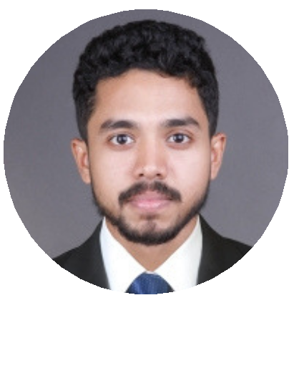

E D U C A T I O N

Anna University - Bachelor in Engineering, Electrical & Electronics 2015.
Diploma in Industrial Safety from N.I.L.E.M

Maxwell Electric Corporation, Thrissur Kerala
Electrical Engineer
OCT 2018 - NOV 2018
Project
Site : Steel Industrial & Forgings Pvt. Ltd Thrissur
● Replacement of OCB and Supply and Installation of new VCB Panel (1 Incomer & 2 Outgoing)
● Oil filtration of 1000 kVA Transformers
Responsibilities:-
Planning and execution of various site activities according to the project electrical drawings.
Supervised installation of Electrical Services.
Supervised installation of HT & LT Cable glanding including termination.
Coordinated with local government authorities like KSEB and
Electrical Inspectorate for the necessary approvals.
Testing relays, Charging and Handing over various electrical items to the client.
Do the necessary co-ordination and report to the direct supervisor regarding the variations of scope of work.

T E C H N I C A L S K I L L S

Inspections & test plans
Documents review
Noting & file management Drafting & Designing Interpreting drawing and specification
Networking & Systems
Administration
Supervision & coordination

L A N G U A G E S K N O W N

English Hindi Tamil
Malayalam

T R A I N I N G S &
I N T E R N S H I P

DHL Eranakulam , India
Systems Engineer
JUN 2016 - OCT 2017

Configuring and Maintaining Desktop computers, laptops,
Tabs.
· Installing, Troubleshooting and configuration of windows
XP, Windows 7 and windows 10.
Installing and updating antivirus and patches. Administrating computer user account as per company policy.
Installing MS office 2007, 2010 and packages.
Installing configuration and troubleshooting of MS outlook.
·Installing and configure company software and third party software as per customer request take back up of mail and other file as per request from user.
Getting the spares intended for replacement.
Tracing out the faulty spares having hardware issue.
Help DHL team to enter data bill and invoice on their site. Follows mails and providing daily updates to the user about the status of their call.

I T S K I L L S

MEP REVIT AUTOCAD MS OFFICE CCNA

A C A D E M I C D E T A I L S

CCNA - Eranakulam AutoCAD -CAD CENTER Eranakulam

BE / B.tech - Electical & Electronics Engineering at
Anna University Chennai India 2015
12th - Koodali HSS Kerala India 2011

R E F E R E N C E

Available upon request
Personal Information

Date of birth - 27 April 1994
Nationality - Indian Marital Status - Single

