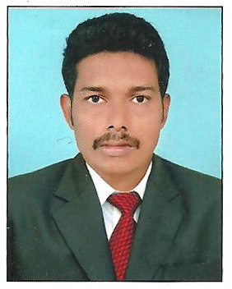
SOORAJ

Email: sooraj.389889@2freemail.com
Career Objective
“To Work in a challenging and creative environment where I would like to contribute towards the goals of the organization”
PROFILE

- Marketing Manager at Jasos Traders for a duration of 1 year.
- 1 year experience as Management Assistant at Mcdermott, Dubai
- 3 years as HR Assistant at Vishal Infrastructure(P) Ltd.
- SKILLS : Tally, Peach Tree, PG DCA
- Professionally qualified with MBA(HR & Finance), B.Com (co-operation).
- Holds STED COUNCIL Diploma certification in Professional Accounting (ISO 9001:2008 certified).
PROFESSIONAL EXPERIENCE

POSITION: Marketing Manager at Jasos Traders (JANUARY 2018 – JANUARY ’19)
- Searching new ventures and Convincing clients for Tender Quotation & Sales.
- Execution of tender and timely deliverance of products in a systematic way.
- Finding out technical solutions for real time problems at and after installation of products (Theatre & Auditorium Luxury Chairs ).
POSITION: Management Assistant at Mcdermott, Dubai (Jan 2017- Dec 2017)
- Co ordinate workers in Warehouse, Store.
- Manage supply, distribution chain of the products at Warehouses and Stores.
- Supervising sub ordinates during manufacturing cum production activities.
POSITION: HR Assistant at Vishal Infrastructure(P) Ltd (April 2013 - Dec 2016)
- Assisted full activities of Hr Dept. for preparing & scheduling contracts.
- Preparations of pay rolls in accordance with their duty schedules.
- Allocating employees and laborers in accordance with the requirement and fixing their shift duties.
- Contacting with the labors and solving their grievances with the organization.

EDUCATIONAL QUALIFICATIONS

Qualification | Institution | Year of Passing | Board / University | Division
MBA(Human Resource Management,  Finance) | DHANALAKSHMI SRINIVASAN ENGINEERING COLLEGE, PERAMBALUR | 2012 | ANNA UNIVERSITY | I Class
B.com | FMNC,KOLLAM | 2009 | KERALA  UNIVERSITY | III Class
Higher Secondary | S M H S S  KOTTARA | 2004 | HSE  board | III Class
SSLC | Govt. H.S S VAKKANADU | 2002 | STATE  BOARD | III Class

personal profile

Date of Birth : 31-05-1987
Age : 31
Gender : male
Nationality : Indian
Languages known : English , Malayalam & Hindi

