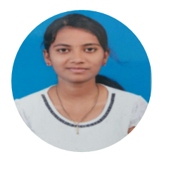 |  | CAREER OBJECTIVE  - To achieve a relevant position in the banking sector using all my expertise in the field of Banking.
PROFILE  Kanniya  Email: kanniya.389934@2freemail.com  Hobbies  - Origami  - Listening to Music  - Cooking  - Gardening |  | QUALIFICATION  Amrita school of Engineering, Coimbatore  2012 – 2016  Sivakasi Nadar Higher Secondary School, Madurai  2010 – 12  - Krishnammal Ramasubbaiyer school, Madurai  EXPERIENCE IN AREA  JP Morgan Chase and co  [KYC Specialist]  September 2018 – March 2019  - Worked as a document reviewing specialist in the commercial banking sector.  - Verified the documents like CRA, COI and BSC.  - Rectified the errors and escalated the inappropriate documents.  - Accumulating the data and updating the details in navigator.  - Tools used in accumulating data “SERVICE PORTAL and CUSTOMER KNOWLEDGE CENTRE”.  Standard Chartered Global Business Services  [Client care Executive]  April 2017 – August 2018  - Working as a Client care Executive and handled Retailed Banking.  - Handled KYC cases of the clients and educated them the importance and role of KYC with respect to banking.  - Worked as a Coach by training the new joiners learn the entire process and helped them deal with the customer data.  - Retained the clients by sharing the benefits of other products and services.  Role and Responsibility  - Strong team player  - Great innovative/creative ideas  - First Satisfied to work in Customers  Hinduja Global Solutions  [Customer Relation Officer]  August 2016 – March 2017  - Worked as a Customer Relation Officer and handled inbound calls for India’s No.1 Network “AIRTEL”.  - Retained clients with the help of other services.  SKILLS  - Japanese (Beginner)  - C programming  - Microsoft Office (Excel, Word, PowerPoint)

