ANANTHA KRISHNAN
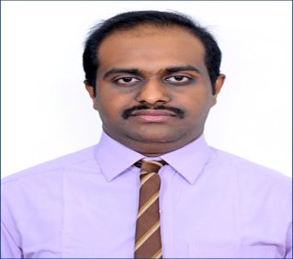

Email: ananthakrishnan.389943@2freemail.com

CAREER OBJECTIVES:

Seeking a career to utilize My Knowledge, personal skills to gain Comprehensive Understanding of a Reputed Organisation so as to Take Responsibility and Contribute Significantly.

ACADEMIC QUALIFICATION:
COURSE | INSTITUTION | BOARD/UNIVERSITY | PERCENTAGE | YEAR OF PASSING
H.S.C | Vivekananda Hr.Sec.School, Puducherry. | Tamil Nadu State Board | 89.75 | March 2012
S.S.L.C  (state board) | Sri  Sankara Vidyalaya  Puducherry  . | Tamil Nadu State Board | 72.60 | March 2010
B.C.A | Achariya Arts and ScienceCollege,Villianur,  Puducherry | Pondicherry University | 55.28(Main) | December 2015
MBA | Christ College of Engineering and Technology | Pondicherry University | 69.70 | June 2018

TECHNICAL SKILLS:
- Languages: C,C++,Data Structure completed at NIIT, Puducherry
- Passed Typewriting Both Junior and Senior in English with Distinction and I Class
- Completed SAP FICO – ERP with A-Grade(Excellent) in CODEDION TECHNOLOGIES, CHENNAI through Creating Experts(The Education Partner)

INPLANT TRAINING & INDUSTRIAL VISITS:

- Underwent implant training at Local Administration Department of Puducherry Government for a period of 3 Weeks

- My projects BCA using On-dine purchase shopping and MBA using topic Service Quality with company “Exide Care Battery Zone”.

SOFTWARE EXPOSURE:

- Completed Certified Core Programming at NIIT, Puducherry Campus.
- Certificate of Proficiency issued by Puducherry E Governance Society on completion of Employ ability Skills Development Programme.

STRENGTHS:

- Adaptability,
- Punctuality,
- Confidence,
- Hard working,
- Optimistic.

HOBBIES AND INTEREST

- Playing Shuttle Badminton
- Volley Ball and
- Drawing.

LANGUAGES KNOWN

- Tamil- to read, write and speak,
- English- to read, write and speak,
- Hindi- to read and write,
- French- to read and write and

PERSONAL DETAILS:

Gender : Male
Nationality : Indian
Date of birth : 21st February 1995

