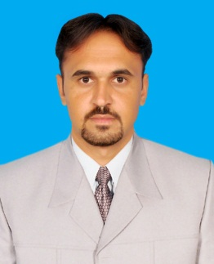 | Hassanain  Email : hassana-389972@2freemail.com

Objective:
Seeking an opportunity in dynamic organization where I can fully utilize my potential, knowledge as well as experience in that environment, which can be challenging & progressive.
Experience/training:
Organization: NETKOM TECHNOLOGIES (Pvt).Ltd (Huawei)
Department: Fixed Network
Project: Safe city
Tenure: March 2017 to November 2017
Designation: Data-com Engineer
Location: Lahore Pakistan
Resposibilities:

- To assemble and install camera poles (IPNV, RLMS).
- Have workable knowledge to install setup for a VOIPs (Huawei ip phones) network.
- Worked on Huawei equipment including Switch (S2700) and Router (AR2200).
- Configuration of routers and switches.
- Installation of ODF, Optical fiber laying and security alarm patching.
- Cabling of CCTV cameras.
- Performed QC tasks and sites sign in/out and their verification using Huawei ISDP.

- Installation of ACDB.
- Installation of batteries bank for UPS.
- Installation of UPS.
- Documentation.
- Preparation of audit reports.
- Site supervision.
- Equipment receiving and delivery to the site
Organization: Turn O Tech (Huawei)
Department: Operation and Maintenance
Project: Safe city
Tenure: May, 2018 to Dec 2018
Designation: Field Engineer VMS
Location: Lahore Pakistan
Resposibilities:
- Maintenance of VMS (Variable Message System) Poles.
- Maintenance of security IP Camera poles.
- Using VFL detect the Optical fiber cut and repair the break.
- Troubleshooting of CCTV cameras.
Academic Qualification:
Qualification | Year of Completion | Major Subjects/  Specialization | Board/University
BSc (Electrical Engineering)  4 years program | 2016 | Electronics | UET Taxila
Intermediate | 2011 | Pre-Engineering | BISE Kohat
Matric | 2009 | Science | BISE Kohat

Skills:

- Autocad Electrical.
- MS Office.
- Secure CRT
- MS Excel.
- MS Power Point
- Visual studio for C++.
- Matlab.
- Proteus software for designing PCB, circuit, and code simulation.
- Basic Knowledge of HVAC

Certification:
Cisco Certified Network Associate (CCNA)
Final year project during study:
- Intelligent UPS with wireless load management syste (Final Year Project)
(The UPS has the ability to sense the voltage of the battery and auto shut down and power ON the connected load according to the available capacity of the battery)
Communication Skills:
I can Communicate fluently in the following languages: -

- English
- Urdu
- Pashto

Hobbies & Interest:

- Hiking
- Jogging
- Newspaper reading
- Internet Browsing

