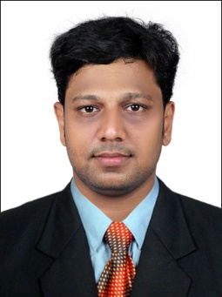
- Sumesh-390000@2freemail.com

SUMESH

To secure a promising, successful and challenging career in the firm where my knowledge and skill can be effectively and efficiently applied to accomplish the tasks entitled to me

Profile Summary
- Confident and self-motivated.
- Can become the part and parcel of agroup.
- Disciplined, dedicated and hardworking.
- Flexible and adaptable to the changing situations and workenvironment.
- Have the ability to learn and imbibe newknowledge.
- Good communication and interpersonalskills.

- Employment History

Organization: Punalur Paper Mills Ltd, India
Designation: Mechanical Engineer
Duration: 21th August 2017 to 28th September 2018
Supervised the processes which undergoes in the Card-Board Production unit of the company.

Organization: The Kerala Minerals and Metals Limited, India
Designation: Mechanical Engineering Trainee
Duration: 09th May 2017 to 11th August 2017
Undergoes training from the Mechanical Department of Titanium Dioxide Pigment unit of the company
Timeline
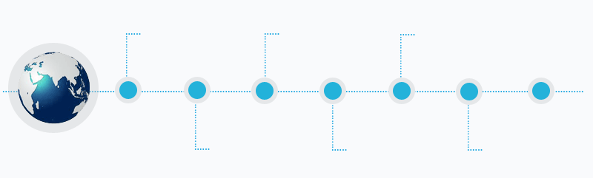
2012-2016BACHELORS OF ENGINEERING IN MECHANICAL ENGINEERING
2017 TRAINEE AT KERALA MINERALS AND METAL LIMITED

2009-2010SECONDARY SCHOOL LEAVING CERTIFICATE EXAMINATION
2017-2018 PUNALUR PAPER MILLS LTD
2016 - 2018MBA IN OPERATIONS AND PROJECT MANAGEMENT
2010 – 2012HIGHER SECONDARY EXAMINATION

Internship

Organization: Cochin Shipyard Limited, India
Duration: 10 days

Industrial Visits

- The Kerala Minerals and Metals Limited, India
- Prakash Body Construction Company, India

IT Skills

Operating System: All Desktop Versions
Package: MS Office Suite (Word, PowerPoint,Excel)
Area of Interests

- Production
- Maintenance
- Automobile Industry
- Energy System
- Oil and Gas
- Mechanical Design
- Management

Educational Qualification

Post graduate Master of Business Administration (Specialized in Operations and Project Management Madurai Kamaraj University, Madurai 2018, Secured First Class
VVM College of Arts, Science and Management Studies, Kottarakara

Under Graduate Bachelor of Engineering (Specialized in Mechanical Engineering ) from
Anna University, Chennai 2016, Secured First Class
Mar Ephraem College of Engineering and Technology, Marthandam

Academic Project

Title: Design and Fabrication of Exhaust Setup for Single Cylinder Petrol Engine.
Institute: Mar Ephraem College of Engineering and Technology, Marthandam

Title: Theoretical Analysis of Solar Panel Construction in The Mechanical Department.
Institute: Mar Ephraem College of Engineering and Technology, Marthandam

Personal Details

Date of Birth: 13th January 1994
Languages Known: English, Malayalam, Tamil
Nationality: Indian
Licence number: 24/2538/2012 (INDIAN)
Marital status: Single

Additional Information

- IELTS SCORE (Speaking 6.5, Listening 6, Writing 6, Reading 5.5)
- Participated and Organized various cultural programs during academics
- Participated in ROTARY YOUTH LEADERSHIP AWARD in 2015
- Participated in various workshops during the academic year
- Interested in watching movies ,playing badminton and surfing the internet

Note
- In case of the requirement for the attested certificate, kindly requesting to provide one month duration for submission.
- Currently availablein the UAE from 21th March 2019, on visit visa.
Declaration

I hereby declare that the information furnished above is true to the best of my knowledge and belief and I am confident of my ability to work in a team.
SUMESH

