CURRICULAM VITAE
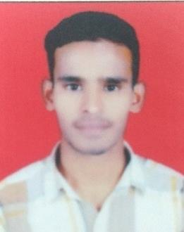

Chand
Email: chand.390009@2freemail.com

Career Objective:

To be a part of the challenging team which strives for the better growth of the organization and which explores my potential and provides me with the opportunity to enhance my talent with an intention to be an asset to the company.

Educational Qualification:

- B.Tech (Mechanical) from JNTUH 2017.

Work Experience:

Jan 2018 to Jan 2019 | HVAC Site Engineer | Swapna Enterprises, HYD India.

About: Swapna Enterprises provides engineering solutions and services in HVAC, plumbing, electrical, building design and drafting for a wide range of industries in Hyderabad and India.

Responsibilities:-

- Itemize daily work schedule; update site contractors about day-to-day duties.

- Liaise with the Purchase Team to follow-up new material purchase; maintain receipt and usage records.

- Perform Quality Check of labor activities and output; rectify errors, if any.

- Ensure proper adherence and compliance with on-site safety measures.

- Resolve client concerns to ensure positive and satisfactory client-stakeholder-company relationship.

- Attend site meetings and review proceedings; put forth any issues or shortcomings being faced on the site.

Technical Qualification:

- Certificate Course in HVAC Systems: Dhanush MEP Centre Hyderabad, India 2017.

- Certificate Course in AutoCAD Dhanush MEP Centre Hyderabad, India 2017

- Certificate course in Ms-office and Advanced Excel.

Page 1 of 2

Strength:

- Have good communication skills, well organized and able to work individual or in a group.

- My positive attitude and commitment towards work will prove to be a valuable asset to your organization.

- Comprehensive problem solving abilities, good verbal and written communication skills.

Software Exposure:
➢ Operating System |  | : | XP, VISTA, Win-7.
➢ Office Automation |  | : | MS-Excel, Word, Power Point, & Access
Personal Profile:
DOB | : | 02/Aug/1994
Marital Status | : | Single
Nationality | : | Indian
Languages known | : | English, Hindi, Telugu.

Page 2 of 2

