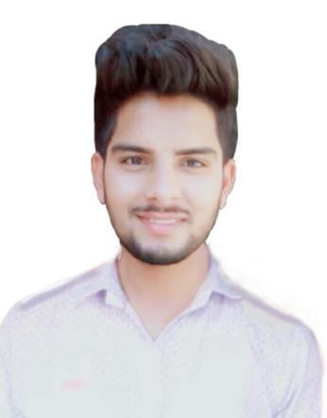
Hardeep

Email: hardeep.390016@2freemail.com

PRO FESSI ON AL S UMMA RY

Deadline Focused Web Design and Project management. Skilled Web designer has Familiar with HTML, CSS, JQuery, Java Script, Responsive Designs, Adobe Photoshop, PSD to HTML, WordPress, Website Speed Optimization, All Bug Fix Related to website.

EDU C ATIO N

- Bachelor of Computer Applications, Punjab University, Chandigarh (2015-18) Punjab, India.

- Senior secondary Examination (12th), S.P.N. Collegiate School, Punjab, India.

EX PE RIE N CE

As Web Designer in WebDesigncontinuum IT Solutions in Duration Three year.

PRO FESSI ON AL S KILLS

- Consistently met deadlines and requirement for all work order.

- Coordinated with system partners to finalize design and confirm Requirements.

- Managed creative projects from concept to completion while managing clients.

- Provided all bug fixes for existing website.

- HTML

- CSS

- JQuery

- Java Script

- Responsive design

- Adobe Photoshop

- wordpress

- All Bug Fixes related to website.

PERS ON AL S KILL S

- Hardworking.

- Positive Attitude.

- Self confidence.

- Problem Solver.

- Change adopter.

- Capability to adapt different situations.

HOBBIES

- Listening Music

- Reading Newspaper

- Surfing on Internet

O T H E R DE TA ILS

- Languages known: English, Hindi, Punjabi.
• Marital Status : Single

