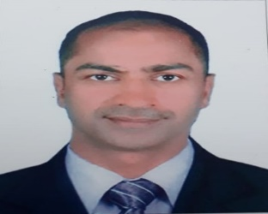

PETRIS
Emal: petris.390035@2freemail.com

OBJECTIVE:
Seeking a career oriented position with progressive organization where my professional experience will enable to make a significant contribution towards company’s goal.

PROFESSIONAL STRENGTH:
Good Communication Skills and Interpersonal Skills • Good Team Work • Quick Learner • Time and Priority Management • Flexible to work under pressure
and also to do any challenging work.

LANGUAGES:
English, Hindi, Marathi, Arabic, Malayalam & Konkani.
Ability to take initiative, to learn and to develop. To adjust quickly in different environment and capable of dealing with clients at various levels and working as a team.

SELF EVALUATION:

Sincere, Confidence and aim to exceed the average and to achieve excellence –Highly motivated and possessing good inter personal communication skills. I assure you that I shall strive to serve the interests of the Company with integrity to the best of my abilities.

WORK EXPERIENCE:
• Worked as a Waiter Hotel Goodman, Colva-Goa from 24th October 1994 to 15th September 1997.
• Worked as a Housekeeping Supervisor at the Emiri Palace, Doha-Qatar from November 1997 to November 2017
• Working as a Waiter in Wild West Restaurant.Curchorem-Goa From 15th January 2018 till date.

QUALIFICATIONS:
SECONDARY SCHOOL CERTIFICATION - Guardian Angel Higher Secondary School Goa Board 1993, with A Grade.

Studied the Course of Fitter at I.T.I Cacora, Curchorem Goa from August 1993 to July 1995

Completed STCW – 95 Courses at Fr. Agnel Maritime Academy at Verna-Goa from 10th February 2003 to 21st February 2003

Completed MS Excel Computer Course at Info-Tech Corporation of Goa Ltd. from 2nd January 2012 to 31st January 2012.

PERSONAL INFORMATION:

DATE OF BIRTH : 09th November,1976
NATIONALITY : Indian
GENDER : Male.
RELIGION : Roman Catholic
MARITAL STATUS : Married

PASSPORT DETAILS

PASSPORT NO. : R=9141325
DATE OF ISSUE : 31.07.2018
DATE. OF EXPIRY : 30.07.2028
PLACE OF ISSUE : PANAJI
MARITAL STATUS : Married

DRIVING LICENSE:
Holding Valid Qatar LMV Driving License valid till 5th April, 2021.

DECLARATION:
I hereby declare that the above information provided by me is true to the best of my knowledge

( PETRIS FERNANDE )

