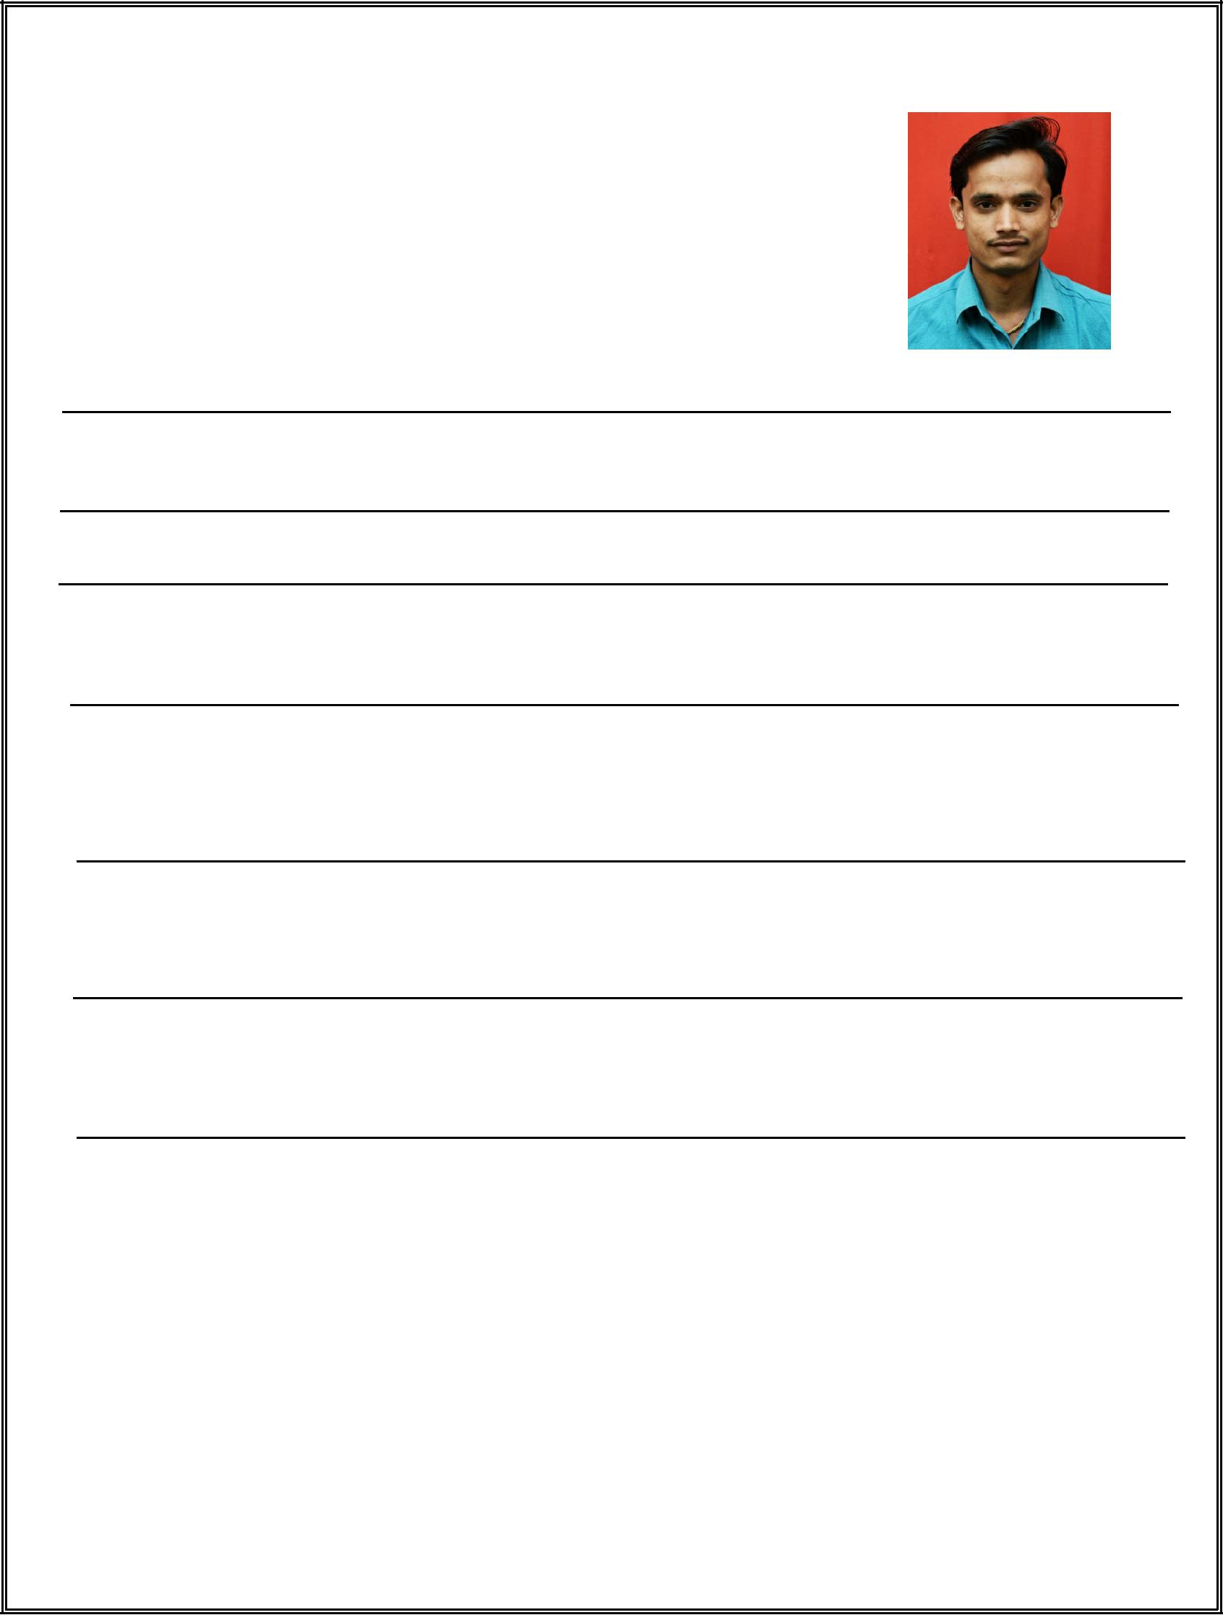
Dnyaneshwar

Dnyaneshwar-390049@2freemail.com

Objective:To expand and utilize my knowledge in the best interest of the organization and self.

WorkExperience:

Company :SREngineeringCo.

Designation :AsASafetyOfficer.

Company :ICICIBANKPVTLTD.

Designation :As a SalesOfficer.

From :May2016To2018.

Company :JETCHEMICLEPVTLTD.

Designation :PlantOperator

From :Jan2015to2016.

Company :SAMARTHPAPER&BOARDMILLPVTLTD.

Designation :Supervisor

From :Jun2014to2015

Company :MAHAONLINELTD.

Designation :Computer operator

From :Feb2011to2014

ComputerProficiency/Professionalskilset

- MSOfficesuite.

- Internet/E-mail.

- TechknowledgeforOfficeautomationComputers.

Fortes:

- TeamPlayer.

- Accustomedtoworkunderpressureconditions.

- Selfconfidence/Selfmotivation.

- FastLearner&Hardworker.

- Good Communication Skils,Capable ofindependentthoughtto accept responsibility.

EducationalProfile:

 | CourseName |  | Passing | Class
 |  |  | Year
 | AdvanceDiplomaInIndustrialSafetyTechnique(ADIST) |  | 2018 | IClass
 | BA-PoliticalScience |  | 2014 | IClass
 | HSC-Arts |  | 2011 | IClass
 | SSC |  | 2009 | IClass
 | PersonalInformation:
 | • Name | :Dnyaneshwarkarad
 | • DateofBirth | :25/11/1993
 | • Religion | :Hindu
 | • Nationality | :Indian
 | • MaritalStatus | :Unmarried
 | • Languagesknown | :Marathi,Hindi,English(Improving)

Date: DnyaneshwarKarad

