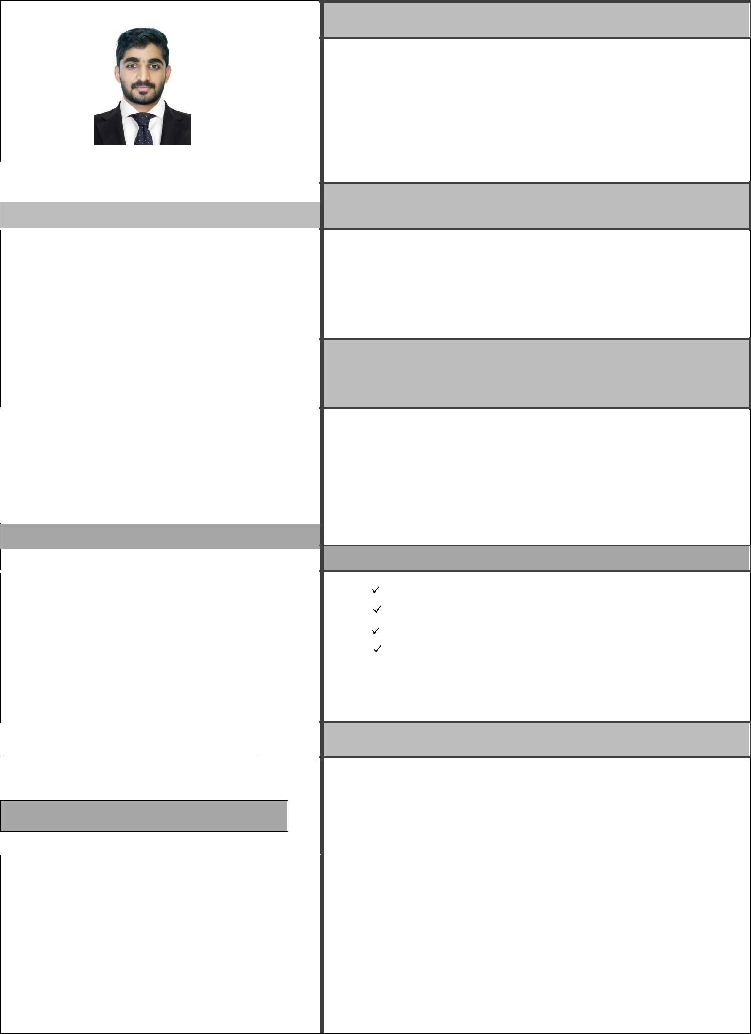

SHARBAZ ABDULLA

- sharbz-390102@2freemail.com

Profile

An adaptable, conscientious, enthusiastic, and self-motivated individual with good communication skill and ready to work both independently and as a member of a team. Now seeking challenging and rewarding opportunity within a successful organization.

Career objective

Looking forward for a very good career breakthrough, which will help me to expand my knowledge and refine my skills so that I can contribute effectively for the growth of the organization.

Computer skills

- MS OFFICE(Excel, Word, Powerpoint)
- Networking Skills and Multimedia

- Adope Premier Pro

- Spectrum-Accounting application

- TALLY

- SAP

Personal skills

Honest

Leadership skill

Responsible

Initiative

Self confidence

Best Manager Participation

Customer Relationship Management

Work Experience

  - CA Suresh &Saju Associates, Leading
- Chartered Accountants Firm, Kannur

  - Office Administrator (SHIYA group of company’s kannur)

  - Purchase Coordinator ( ABC group of India )

  - ABC EMPORIO LLP (DEC2017-SEP2018)

Accounts & Audit Assistant,COCHIN

  - Sales representative (mobile& accessories)

Dhawahi Al-karha trading, OMAN

CURRICULAM VITAE

EDUCATIONAL QUALIFICATION

Examination | Discipline / | School / College | Board / | Year of
 | Specialization |  | University | Passing
MBA | Human Resource | Annamalai | Annamalai | 2019
 |  |  | University
BCom | Computer | Sir Syed Institute for | Kannur | 2016
 | Application | Technical Studies, | University
 |  | Kannur
12th | Commerce | Chinmaya | CBSE | 2013
 |  | Vidyalaya,
 |  | Kannur
10th |  | Royal English | CBSE | 2011
 |  | School,
 |  | Kannur

Language Read Write Speak

English | Yes | Yes | Yes
Arabic | Yes | Yes | No
Malayalam | Yes | Yes | Yes

DECLARATION

I hereby declare that all the statements made in the above Curriculum Vitae are correct to the best of my knowledge and belief.

