PROFESSIONAL

Over 15 years of experience in Operations, specifically in the field of project coordinating, Customer Service, Telecommunications, and administration areas. Possesses excellent communication skills, solid organizational and administration experience, and strong leadership background. Major strengths include people management, account maintenance, complaint handling, and relationship management. A result- oriented person with passion to deliver excellent customer experience to both internal and external customers.

EXPERIENCE HISTORY

Office Coordinator and Account Assistant,

Abu Dhabi.

December 2017 to Present

Handling 300 above AMC contracts all over UAE including Hotels, Hospitals, High Rise Buildings, Villas, and Commercial Buildings.

Job Responsibilities

- Prioritizes planned maintenance schedule to ensure they are completed within deadlines. Oversee the coordination between Abu Dhabi Civil Defense department inspections, attested contracts and renewal of certificates.
- Responsible for preparation of maintenance contracts in compliance to UAE government regulatory requirements
- Preparing planned maintenance schedule and ensure they are completed within deadlines.
- Receiving of site staff’s Daily job reports and entry the details in to the system in daily basis and tracking of work timing.
- Receiving and Tracking of Monthly inspection, updating of Monthly Inspection Control Sheet on daily basis
- Scanning of all monthly, quarterly reports in daily basis and filing
- Monitoring contract renewals and supporting to contract manager
- Preparing necessary documents for the Invoices
- Monitoring and recording of Invoice summations and Receiving of Supplies Invoices
- Follow up pending payments in daily basis and arrange to collect all the payments
- Replying to Emails
- Sending necessary reports to clients
- Managing Work related complaints of the site staff and engineers
- Managing all subcontractors
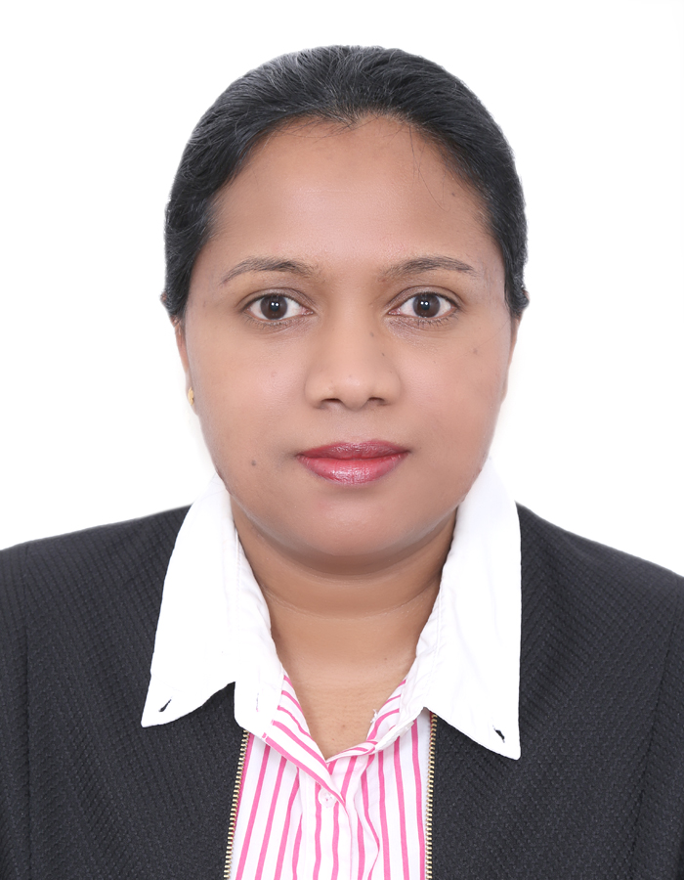
Ganga-390119@2freemail.com

EDUCATIONAL QUALIFICATIONS

- Certificate of Education Ordinary Level, Board of Education, Sri Lanka

- GCE (Advanced Level-High School), Board of Education, Sri Lanka

OTHER QUALIFICATIONS
- Diploma in Information Technology, Turnkey Computer Center Sri Lanka

TEHNICAL SKILLS

- MS Office Applications, Facts ERP System
- Visual Basic, Web Page Designing, PageMaker & Photoshop

PERSONAL DETAILS
Nationality: Srilankan
Date of Birth: 14.03.1976
Marital Status: Married
Languages:
English, Hindi & Sinhalese

Project Coordinator, Easy one Facilities Services, Dubai (March 2016 to November 2017)

Project Coordinator, MAB General Maintenance, Dubai (January 2011 to February 2016 )

Job Responsibilities:

- Covers all aspects of facility management, real estate services, building and , projects
- Responsibilities include programmatic administration, coordination and management of projects, budgetary oversight, facilities management, and leadership of programs and services.
- Functions include specialized architectural, engineering, site, and construction services; project scheduling, estimating, and support of operations and maintenance.
- Provides and implements processes and programs to provide optimal productivity of facilities team
- Coordination of all program rollouts
- Develops business cases for facilities projects and presents to all approval committees
- Manage all facilities preventative maintenance programs, including scope of work, specifications, and quality assessments.
- Schedule preventative maintenance, respond to urgent maintenance calls and participate in the creation of emergency preparedness plans
- Handle all Documentation and manage general administration.
- Controlling the project documents and entering to Facts ERP System (Daily Basis)
- Receiving & Scheduling the complaint calls from the clients. ( Private and AMC)
- Coordinate with Operations team for all Emergency Calls received
- Preparing quotations as per the site survey reports using Facts ERP System
- Follow ups all the quotations sent to the clients
- Checking & Sending Emails to the clients ( Private and AMC)
- Coordinating with the clients ( Private and AMC) for Arranging the appointments
- Managing/Organizing the daily work schedule for the Operations Team
- Monitoring all Big and Small ongoing projects until completed.
- Coordinate with the project in charge & site staff for whatever documents or manuals essential in the maintenance field (i.e., Site survey report, Daily reports, Quotations).
- At the time of completion the projects Preparing the documents for invoicing & coordinate with accounts department
- Managing all subcontractors

Admin Executive, M/s. TAV Gulf Tepe Akfen Investments & Constructions), Dubai ( 2004 March to 2010 December )

Job Responsibilities:

- Responsible for day to day operations, streamlining process issues, ensuring consistency over performance in line with Statement of Work.
- Segregation of duties, adherence to the policies and procedures, recognize and reward opulent efforts and regular team meetings.
- Identify and lead new initiatives across processes, formulate and maintain detailed administrative and procedural documentations ensuring accuracy, predictability and stability.
- Responsible for planning, coordinating, review and guiding of team work at various assignments at a regular basis.
- Acted as primary point of contact between clients & the contractors.
- Manage customer centric operations & ensuring customer satisfaction by achieving delivery & service quality norms.
- Coordinate with other Marketing, Public Relations, Sales and product management resources.
- Serve as a liaison between the customer and various departments.
- Responsible for handling queries, incoming and outgoing calls, faxes and mails.
- Retrieving, reviewing and distribution of mails to all staff and other departments.
- Attend briefings, trainings/refresher sessions and meetings as required.

Project Coordinator, Easy one Facilities Services, Dubai (March 2016 to November 2017)
Project Coordinator, MAB General Maintenance, Dubai (January 2011 to February 2016 )

Job Responsibilities:
▪ Covers all aspects of facility management, real estate services, building and , projects
▪ Responsibilities include programmatic administration, coordination and management of projects, budgetary oversight, facilities management, and leadership of programs and services.
▪ Functions include specialized architectural, engineering, site, and construction services; project scheduling, estimating, and support of operations and maintenance.
▪ Provides and implements processes and programs to provide optimal productivity of facilities team
▪ Coordination of all program rollouts
▪ Develops business cases for facilities projects and presents to all approval committees
▪ Manage all facilities preventative maintenance programs, including scope of work, specifications, and quality assessments.
▪ Schedule preventative maintenance, respond to urgent maintenance calls and participate in the creation of emergency preparedness plans
▪ Handle all Documentation and manage general administration.
▪ Controlling the project documents and entering to Facts ERP System (Daily Basis)
▪ Receiving & Scheduling the complaint calls from the clients.
▪ Coordinate with Operations team for all Emergency Calls received
▪ Preparing quotations as per the site survey reports using Facts ERP System
▪ Follow ups all the quotations sent to the clients
▪ Checking & Sending Emails to the clients
▪ Coordinating with the clients for Arranging the appointments
▪ Managing/Organizing the daily work schedule for the Operations Team
▪ Monitoring all Big and Small ongoing projects until completed.
▪ Coordinate with the project in charge & site staff for whatever documents or manuals essential in the maintenance field (i.e., Site survey report, Daily reports, Quotations).
▪ At the time of completion the projects Preparing the documents for invoicing & coordinate with accounts department
▪ Managing all subcontractors

Admin Executive, M/s. TAV Gulf Tepe Akfen Investments & Constructions), Dubai ( 2004 March to 2010
December )

Job Responsibilities:
▪ Responsible for day to day operations, streamlining process issues, ensuring consistency over performance in line with Statement of Work.
▪ Segregation of duties, adherence to the policies and procedures, recognize and reward opulent efforts and regular team meetings.
▪ Identify and lead new initiatives across processes, formulate and maintain detailed administrative and procedural documentations ensuring accuracy, predictability and stability.
▪ Responsible for planning, coordinating, review and guiding of team work at various assignments at a regular basis.
▪ Acted as primary point of contact between clients & the contractors.
▪ Manage customer centric operations & ensuring customer satisfaction by achieving delivery & service quality norms.
▪ Coordinate with other Marketing, Public Relations, Sales and product management resources.
▪ Serve as a liaison between the customer and various departments.
▪ Responsible for handling queries, incoming and outgoing calls, faxes and mails.
▪ Retrieving, reviewing and distribution of mails to all staff and other departments.
▪ Attend briefings, trainings/refresher sessions and meetings as required.

Secretary, M/s Tharanga Shopping Complex, Sri Lanka- (1998-2004)

Job Responsibilities:
▪ Answer telephones and give information to callers, take messages, or transfer calls to appropriate individuals.
▪ Arrange conferences, meetings, and travel reservations for office personnel.
▪ Compose, type, and distribute meeting notes, routine correspondence, and reports.
▪ Greet visitors and callers, handle their inquiries, and direct them to the appropriate persons according to their needs.
▪ Mail newsletters, promotional material, and other information.
▪ Maintain scheduling and event calendars.
▪ Open, read, route, and distribute incoming mail and other material, and prepare answers to routine letters.
▪ Set up and maintain paper and electronic filing systems for records, correspondence, and other material.
▪ Coordinate conferences and meetings.
▪ Establish work procedures and schedules, and keep track of the daily work of clerical staff.
▪ Provide services to customers, such as order placement and account information.
▪ Supervise other clerical staff, and provide training and orientation to new staff.

Other experiences can be further discuss during interview.

