Daniel  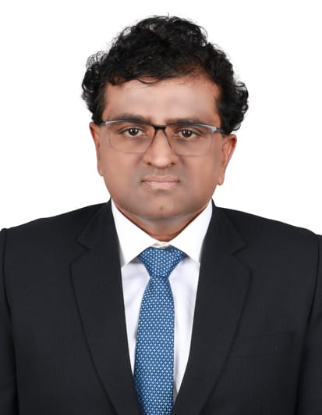  Operations/Administration Professional  Administration  Project Coordination  Operation Management  Email: Daniel.390138@gmail.com  Profile  Highly accomplished and a seasoned professional with 21+ years of experience in the areas of Administration, General Accounts, Coordination and Operations.  Additional Information  - Date of Birth: 18th Feb 1972  - Languages: English, Tamil and Hindi  - Nationality: Indian  - Marital Status: Married  Education  Bachelor in Mechanical Engineering 1995  M.S. Ramiah Institute of Technology, Bangalore University, Bangalore | India  Key Trainings  - SAP Hana – Material Management  - Quality Management System ISO 9001 : 2000 Standard  - Project Management Professional | Core Competencies  - Communication - Basic Accounting - Problem Solving - Risk Management - Material Management - Process Improvement - Project Support - Team Management - Customer Handling - Reporting Preparation - Stakeholder Relationship - Cost Control - Logistics - Negotiation & Influencing  Key Result Areas  Administration  - Capable of performing administrative functions such as scheduling, organizing and maintaining digital files, coordination of team calls and meetings  - Managed general accounting including supporting the preparation of journal entries, reconciling payments, AR/AP and payroll management  - Have handled phone inquiries; provided callers with responses to requests involving departmental inquiries, procedures or programs; directed calls to the appropriate person or takes messages  Coordination  - Coordinating with municipality authorities, stakeholders in articulating necessary information and executing as planned  - Leverage knowledge of computer applications to develop documents including Purchase Orders, business correspondence, and contracts  Material Management  - Proficient in ensuring stock levels are maintained and that other system requests are completedpromptly  - Consistently enforce department policies and procedures and maintaining adherence to the safety procedures in the warehousing areas  - Identifies and executes opportunities for cost reductions for materials  Vendor Management  - Negotiates pricing, provides feedback on service performance, and other relevant aspects of supplier responsibilities  - Managed past due invoice issues with Accounts Payable department

Experience

Chaplaincy of Dubai and Sharjah, UAE
Administrator
July 2009 – March 2018

- Responsible for efficiently discharging the administrative duties as prescribed by the Head of Departments
- Responsible for budget preparation analysis and financial management such as month-end and year-end financial reporting
- Act as a liaison between the Municipality Authorities, Project Consultant, Architect & MEP in soliciting, and resolving outstanding issues
- Managing facility maintenance operation
- Key point of contact in organising the meeting, facilitating meeting logistics and articulating minutes of meeting with the participants
- Accountable for undertaking comparative analysing of techno-commercial offers submitted by vendors, negotiating and finalising orders
- Responsible for issuing Purchase Orders, Material Request Form and other documentation relevant to site management
- Use Advanced Excel in compiling reports and submitting to the top management for their perusal
- Ideated and implement procedures to control cost and insulate the financial integrity of the operations
- Efficiently handled inventory management, ensuring recording of material movement and reporting on discrepancies

Khansaheb Civil Engineering LLC, Dubai,UAE
Project Coordinator
July 2004 – April 2009

- Assist in project planning, budgeting, vendor selection and quality assurance efforts
- Communicate requirements to relevant departments and employees to keep progress on track
- Monitored timelines and flagged potential issues to be addressed
- Assessed vendor products and maintained positive vendor relations
- Conducted and documented weekly status review for upper management

Maxwell Management Consultant, Chennai, India
Procurement Coordinator
Oct 1998 – May 2004

- Handled internal & external resources; thereby ensuring that goods and materials are procured within the framework of the Supply Agreement and also meets schedule requirements

Skoda (India) Engineering Pvt. Ltd., Chennai, India
Purchase Buyer
Nov1995 – Sep 1998

- Liaise with the customer on process improvements, enhancement of customer satisfaction, issue resolution, quality drive
- Maintained open lines of communication between production, sales teams, vendors, and warehouse personnel to expedite product orders, distribution, and problem resolutions

