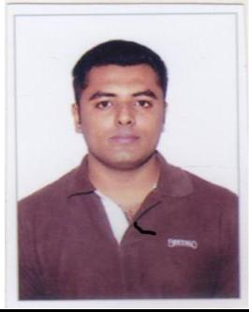

PIRANI

Email: pirani.390208@2freemail.com

SUMMARY

Ambitious Sales Consultant and Customer Representative with over 5 years of experience in education and hotel business, Independent worker with high energy and great communication skills. Motivated and goal driven with exceptional leadership and negotiation abilities.

EDUCATIONAL QUALIFICATION

- Intermediate from St. Joseph Junior College in Apr-2010.
- High School from St. Joseph High School in March-2008.

- Basic computer certificate

- Advance English language certificate

WORK EXPERIENCE

- Worked as a Senior Sales Consultant with Bright Career from Sep-2017 to Jan-2019.
- Sales Executive with IDP India Feb 2014 to August 2017
- Customer service representative with Walnut Hotel from Mar-2011 to Feb-2014.
- Customer service representative with Standard Chartered Bank July 2010 – Jan 2011

JOB RESPONSIBILITIES

- Learn the products and services offered, including the sales terms (e.g. special features, return and warranty policies)

- Set targets for the sales department

- Collaborate with the marketing department to prepare common strategies
- Monitor sales numbers and marketing metrics
- Calculate business trends, like monthly sales rates
- Analyze market trends

- Monitor competition and follow current developments

- Ensure sales team is up-to-date with business targets

- Find prospective customers and new target segments

- Serve visitors by greeting, welcoming, directing and announcing them appropriately

- Answer, screen and forward any incoming phone calls while providing basic information when needed

- Receive and sort daily mail/deliveries/couriers

- Maintain security by following procedures and controlling access (monitor logbook, issue visitor badges)

- Update appointment calendars and schedule meetings/appointments

- Perform other clerical receptionist duties such as filing, photocopying, collating, faxing etc.

- Coordinating the interview process with Recruitment Team.

- Inventory Management

- Vendor Management

- Updating Leave Cards (Maintaining the manual document of the Employees applying for leaves).

- Assisting the HR team in Joining and exit formalities.

- Good communication skill

SKILLS

- Speak and write in fluent English.
- Proficient in Microsoft Office including Excel and Power point.

- Dedicated Worker
- Implement Social Media campaigns.
- Excellent written and verbal communication skills.
- Excellent editing
- Can handle work pressure

- Can work long hours

- Flexible shifts

PERSONAL DETAILS:

Nationality | : | Indian
Date of Birth | : | 16-Jul-1992
Gender | : | Male
Marital Status | : | Single
Language Known | : | English, Hindi, Gujarati & Urdu
Visa Status | : | Visit Visa

REFERENCES

References available upon request.

