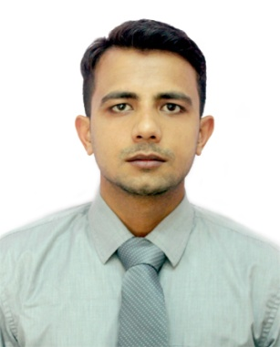
Curriculum Vitae
SHAHBAJ

E-Mail: shahbaj.390236@2freemail.com

Career Objective

Looking for an opportunity to associate with a progressive organization to utilize my skills and knowledge according to the trends and dynamically works towards the growth of the organization.

Experience

Customer care & Sales Executive at Aman Enterprises
(15 October 2016 to 20 Feb 2019)
- Online Hotel, Sightseeing and Air ticket bookings.
- Tour packages bookings.
- Tour packages presentation (In MS Word) and Sale to customer.
- Responded to customer queries.
- Work on Travel Triangle & Look and Book Portal.
- Manage E-mails and Customer documents for VISA.

Professional Qualification

- 6 Months Diploma in GDS Amadeus and Travel Management.
- 1 Year HCE Certificate in Computer.
- WINDOWS 7 Configuration (MCTS)

Academic Qualification

- Graduation (B.Sc.) from MJPR University.
- 12th (Science) from BGDAI College.
- 10th (Science) from JI College.

Skills
- Active Listening & Responsiveness
- Telephone Etiquette
- A Calming Presence
- Goal Oriented Focus
- Ability to Handle Surprises
- Easily operate online Websites and Portals.
- MS Word (2007)
- Basic MS Excel (2007)
- Basic Troubleshooting of Software’s
- Installing and Operating Windows 7, 8 and XP.
- 25 WPM Typing Speed Approx
- Team Viewer, Nero Etc.
- Knowledge of File compressing and Changing File format Etc.
Hobbies

- Talking to people
- Travelling

Strength

- Positive Attitude
- Quick learner
- Self-Motivation
- Co-operative
- Dedication towards my work
- Punctual
- Flexible
- Cool Minded

Language Known

Language | Write | Read | Speak
Hindi | Excellent | Excellent | Excellent
English | Excellent | Excellent | Good
Arabic |  |  | Beginner

Personal Details

- Date of Birth : 25/09/1991
- Gender : Male
- Nationality : Indian
- Marital Status : Unmarried

